VISIT ON EVENT “ACTIVAL FOR FUTURE” IN LUBECK,GERMANY ORGANIZED BY SOLIDARITY ACTION DAY MOVEMENT

President of the Assembly, Danilo Popovic; secretary of the Assembly, Milica Miranovic; former Coordinator of North Region, Biljana Mircic and three delegates Aleksandra Jovovic, Jelena Mitric, Sara Avramovic visited Actival for future in Lubeck, Germany from 2nd May to 6th May 2019. They there met with the grading board of SAME and youth from all over Europe to try to make plane for better future.

The main purpose of this travel was to contribute in making changes and raising voice of young people all over the Europe. Also the UNSCG delegation had chance to speak with their peers from Balkan and make more contact as people from new governing board were there. At the main event on the city square in Lubeck, they had chance to publicly write their ideas on the “wall” so everybody can see and hear about them.

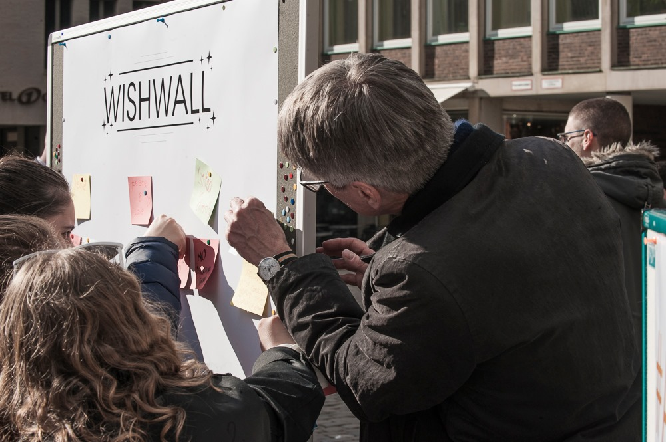

High School Students Union of Montenegro was also presented to others as the youngest organization implementing the “Solidarity Action Day” and the team member Milica Miranovic spoke publicly in a debate with representative of the country implementing the Solidarity Action Day the most, the Norway (they are doing it for 50 years). The main difference was that money collected from AD in Montenegro is helping Montenegrin citizens and the money they have made in Norway goes to a worldwide group which apply for it.

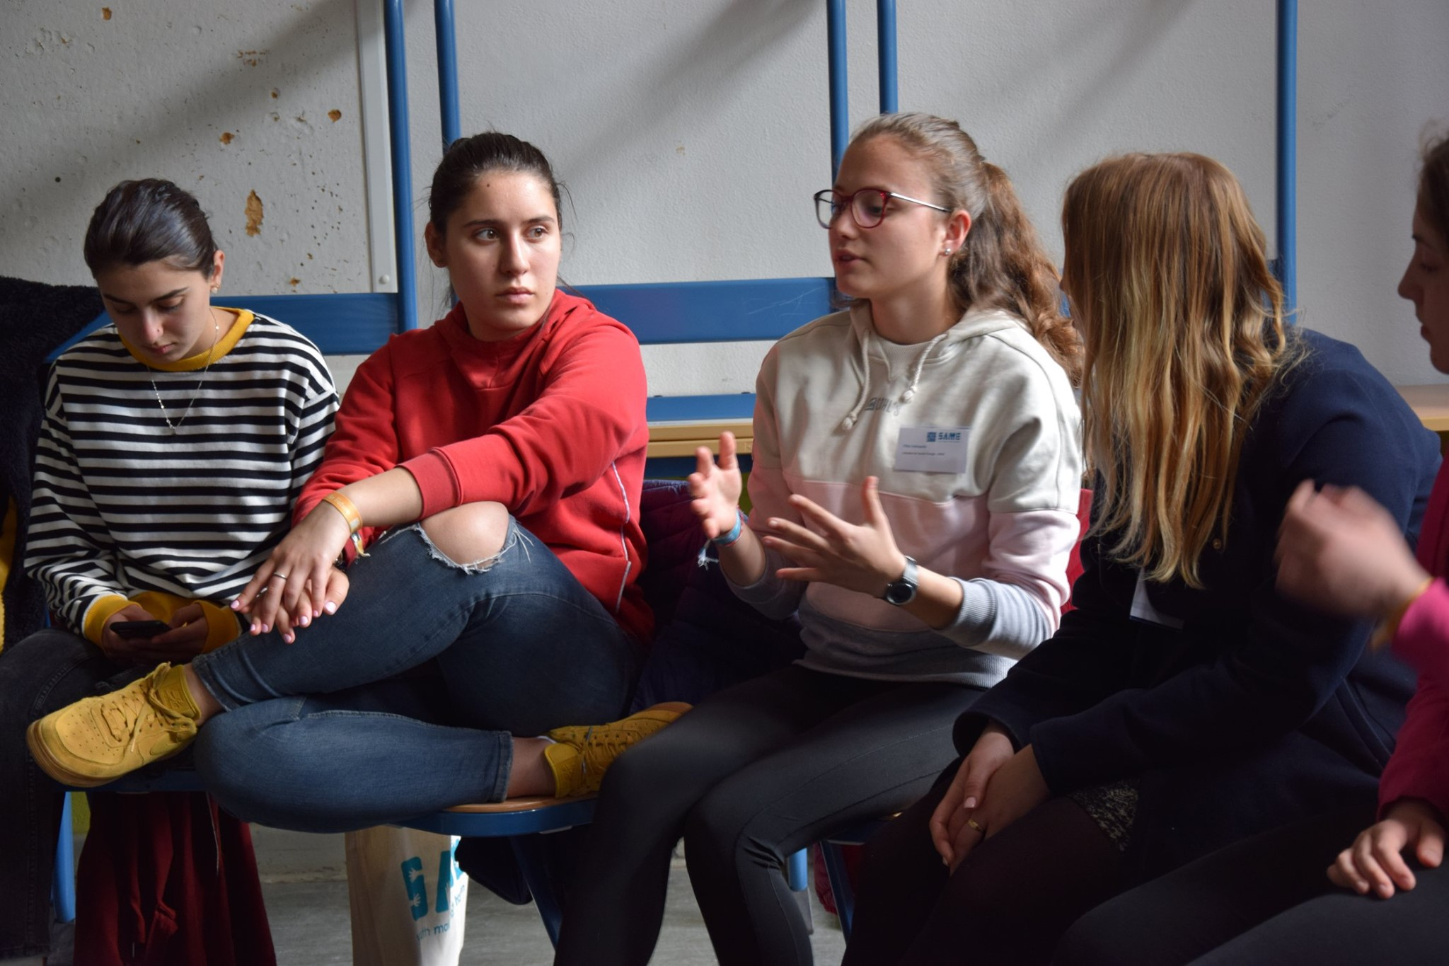

The Actival for future was very useful for people from UNSCG in developing their ideas for further improvement in organization leading and for implementing the ideas faster and better for Montenegrin high school students.

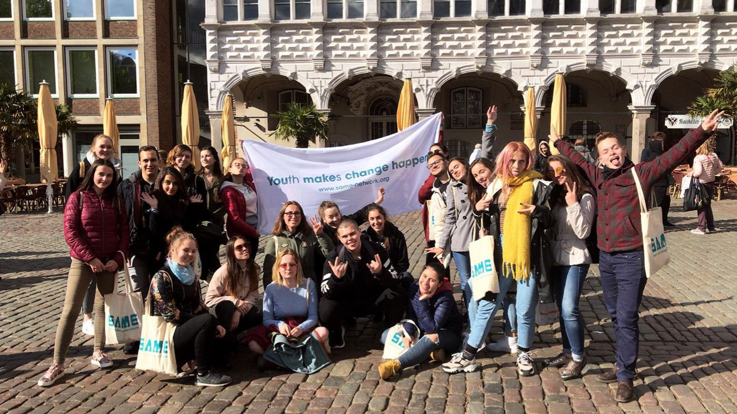

Action day 2019 – Central region

On the 10th of May 2019, Action day was organized in Podgorica. This project had the support of around 20 firms and around 100 High school students. The students applied through a website we created for this purpose, and they had only words of thanks for the application process. The organization of this event went smoothly. Members of the board of directors were able to go to every partner firm and check on our high school students, as well as hand in the certificates and thank you cards to the partners that participated in the project. We have amazing comments from our high school students, they enjoyed their time working with our socially-aware partners, while the partners thanked the students on their time and congratulated us on the organization of event.

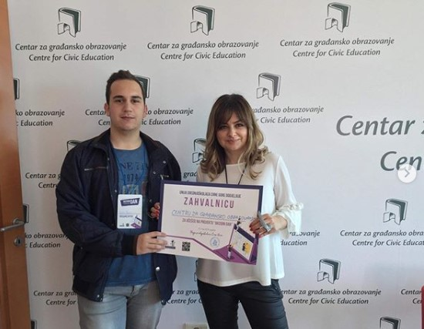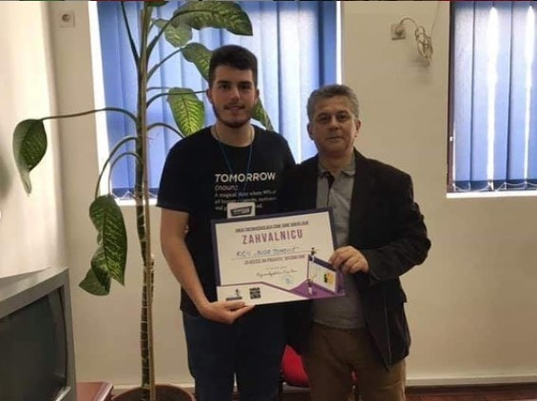

Steering committee members handing in certificates to the partners

This part of the project involved students from 8 different schools and it was able to raise 1100 euros for the Action day fund. The Action day fund will later finance the best project ideas of the student parliaments.
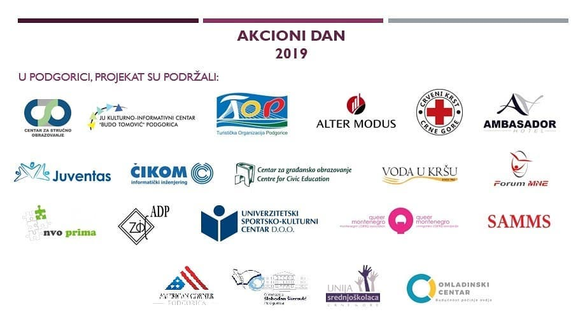
Partner firms that supported Action day 2019 in Podgorica

Announcement on social media:
https://www.facebook.com/watch/?v=359317241357205

Action day 2019 – North Region

On the 10th of May 2019, Action day was organized in Berane, Plužine, Mojkovac, Rožaje, and Bijelo Polje. This project had the support of around 23 firms and around 110 High school Students. The organization of this event went smoothly in every town for the north region. The students applied through a website we created for this purpose, and they had only words of thanks for the application process. We have amazing comments from our high school students, they enjoyed their time working with our socially-aware partners, while the partners thanked the students on their time and even offered some of them summer jobs. High school students handed in the certificates and thank you cards to the partners that participated in the project since our coordinator for the north region was not able to go to all of the cities in this one day.

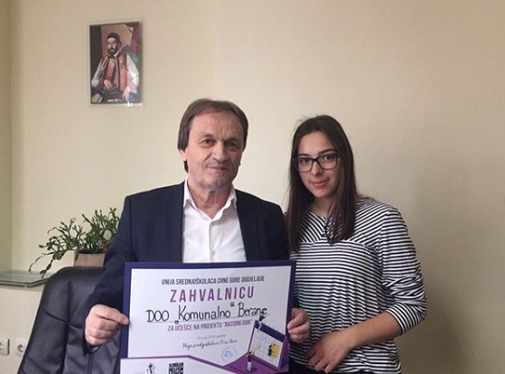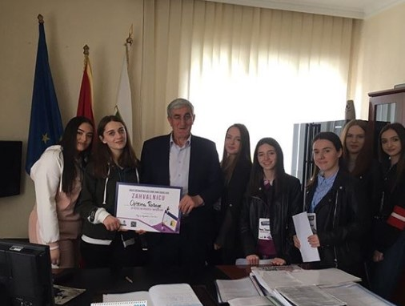
High school students handing in certificates to the partners

This part of the project involved students from 7 different schools and it was able to raise 1100 euros for the Action day fund. The Action day fund will later finance the best project ideas of the student parliaments.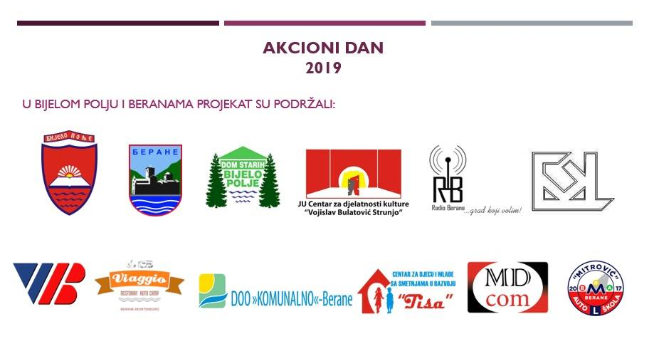
Partner firms that supported Action day 2019 in Bijelo Polje and Berane

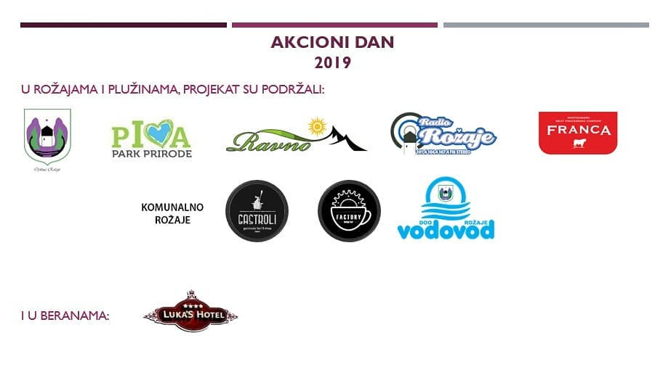
Partner firms that supported Action day 2019 in Rožaje and Plužine

Announcement on social media:
https://www.facebook.com/watch/?v=359317241357205
https://www.instagram.com/p/BxSDYqegm72/

ACTION DAY 2019 - SOUTH

This year Action Day was the largest one that we organized. In the south region of Montenegro, in the municipalities of Herceg-Novi, Tivat, Budva, and Bar we had ---- companies where our .... volunteers worked. We are more than happy that some national companies offered us workplaces in multiple towns and also grateful to the defense ministry that besides everything that they have done and provided for us, decided also to make a substantial donation to our project. This all wouldn't be possible without the work of the entire team of people and our volunteers. Many of the volunteers have remained in contact with their employers and got a summer job. The Union of High School Students is predicting an even bigger Social Day next year and we couldn't be happier for the feedback we are getting from the employers and volunteers.

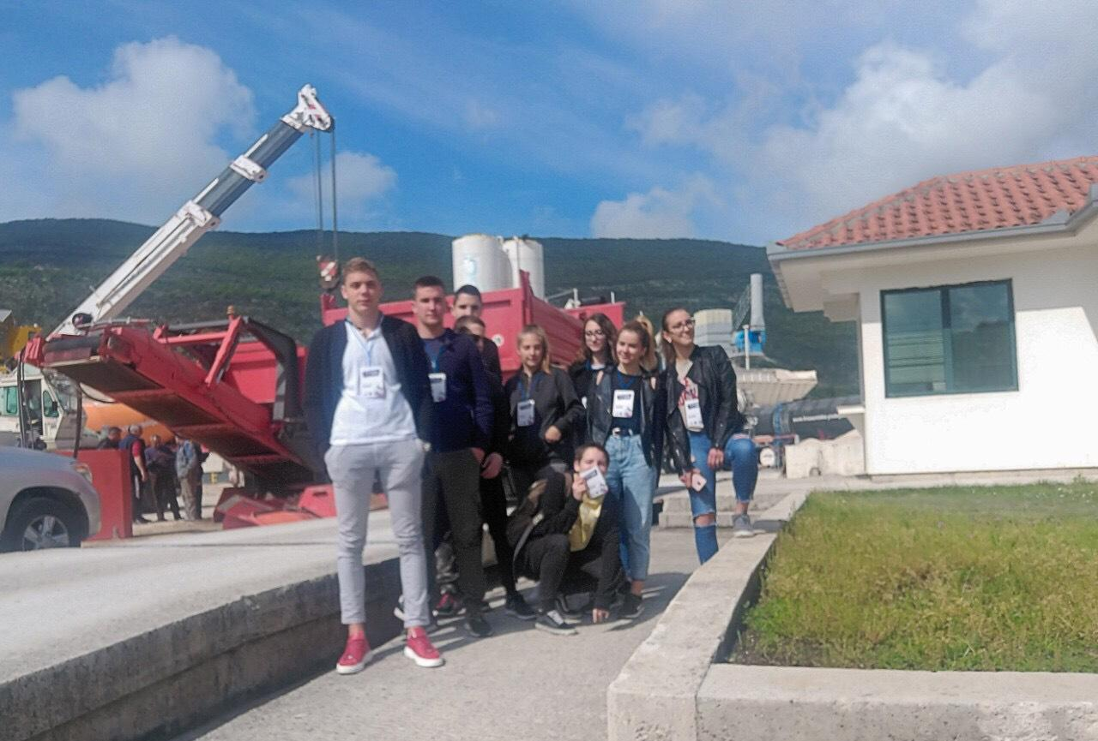
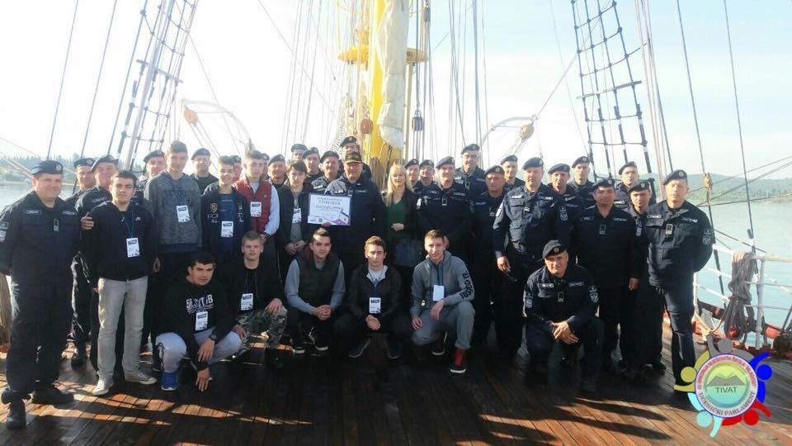

WFD SEMINARS

The High School Student Union of Montenegro understands the importance of successful communication and collaboration between NGO and government sector. That's is why representatives of our organization Andrea Micanovic and Bogdan Malavrazic took part in a number of seminars organized by the Westminister Foundation for Democracy with the goal of finding a project in which both sides can take equal responsibilities and improve communication.

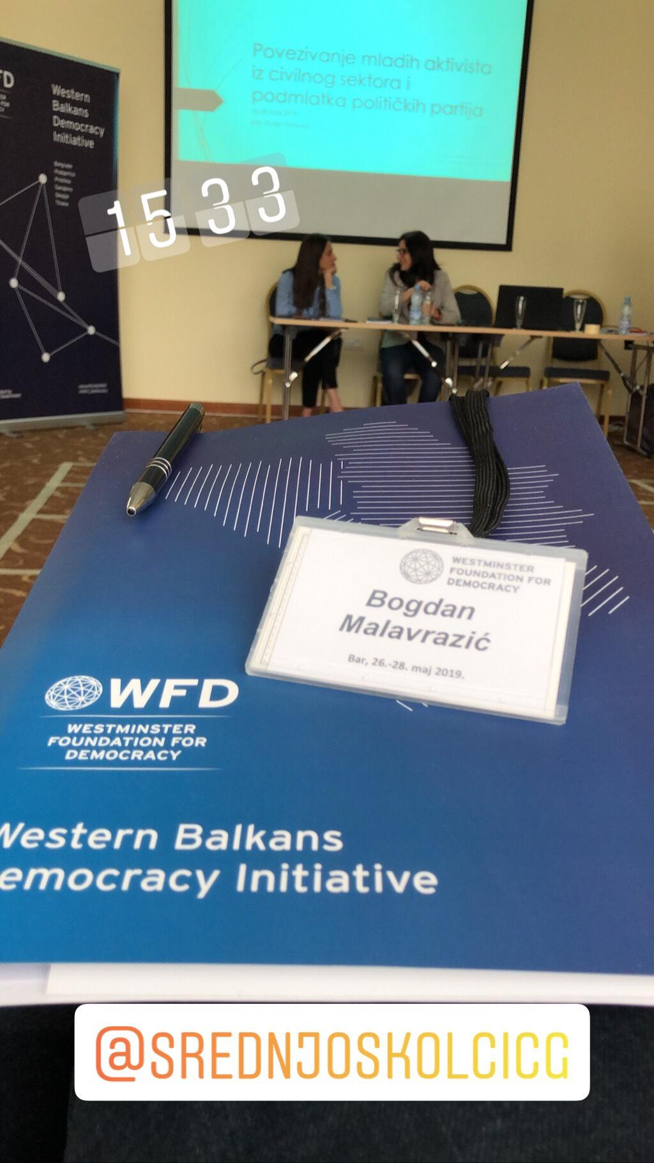
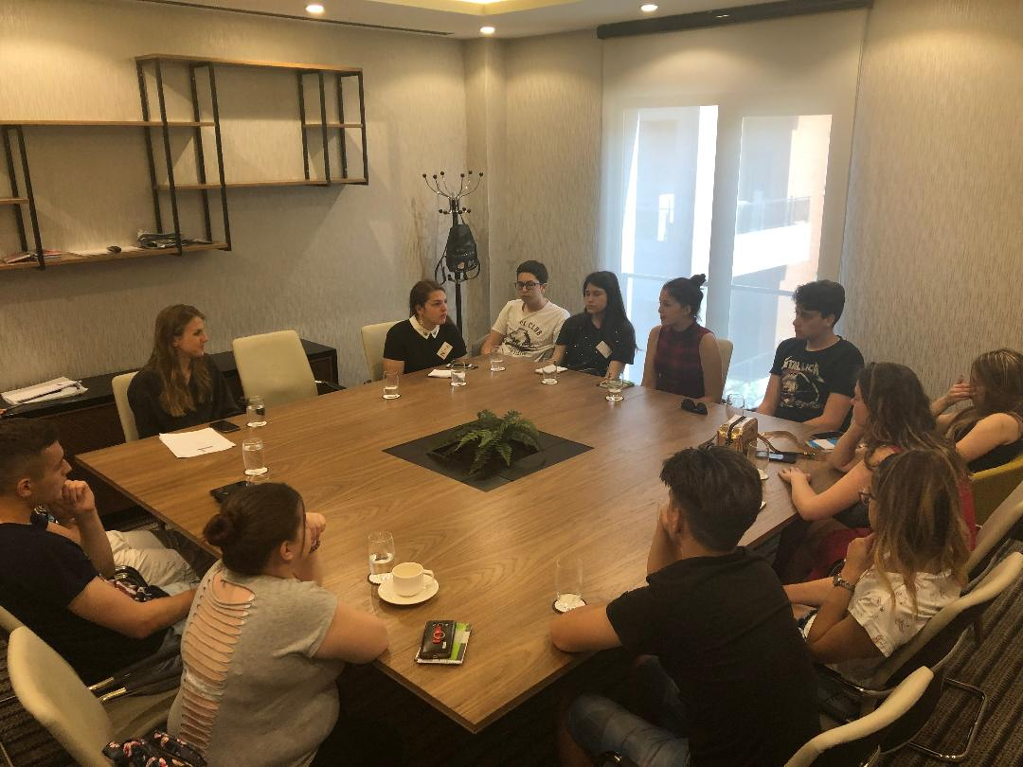

FLEX

The Alumni organization of FLEX (Future Leaders Exchange) program student invited the representative's od The High School Union of Montenegro to be Mentors at a seminar that they organized. We accepted the call and sent Balsa Bozovic and Andrea Micanovic to teach about team building and professional and adulting skills. The seminar took place in Podgorica and was funded by the State Department Grant. As a part of their seminar students also visited the Youth center and learned more about the work that the Union is doing. We expect further cooperation with the Alumni of this program.

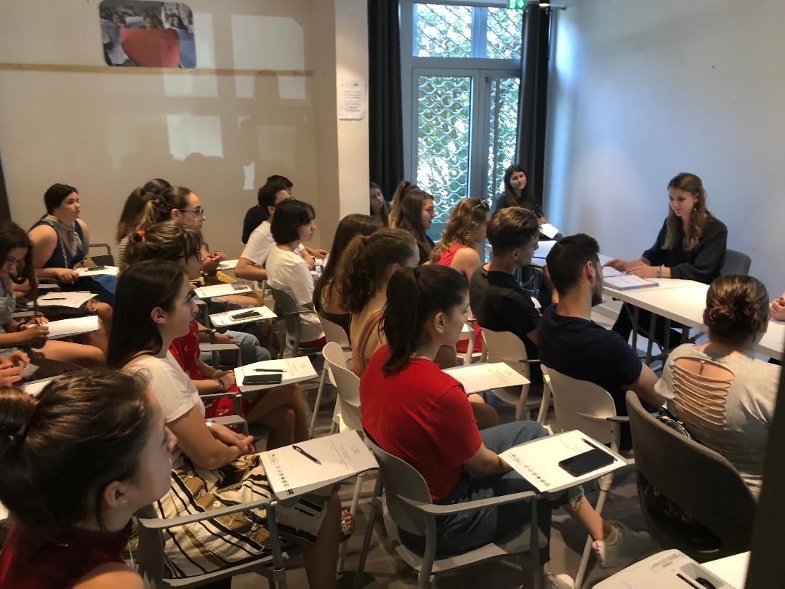

ACTIVATE YOURSELF TOO

Association of pedagogues of Montenegro, with cooperation of High School Student Union of Montenegro, carried out a project called “Aktiviraj se i ti” (“Activate yourself too”). The project is supported through the program "For a stronger voice of civil society organizations", implemented by Fund for active citizenship and funded by U.S. Embassy in Montenegro.
The project activities consisted of two two-day trainings in project writing. Pupils of 5 high schools participated. The trainings covered budget planning, planning of activities, setting up goals as well as monitoring and evaluation of project. After the two trainings, they were given a task of writing a project that could be implemented in their schools. Three out of five projects got funded, and were monitored by members of Association of pedagogues of Montenegro.

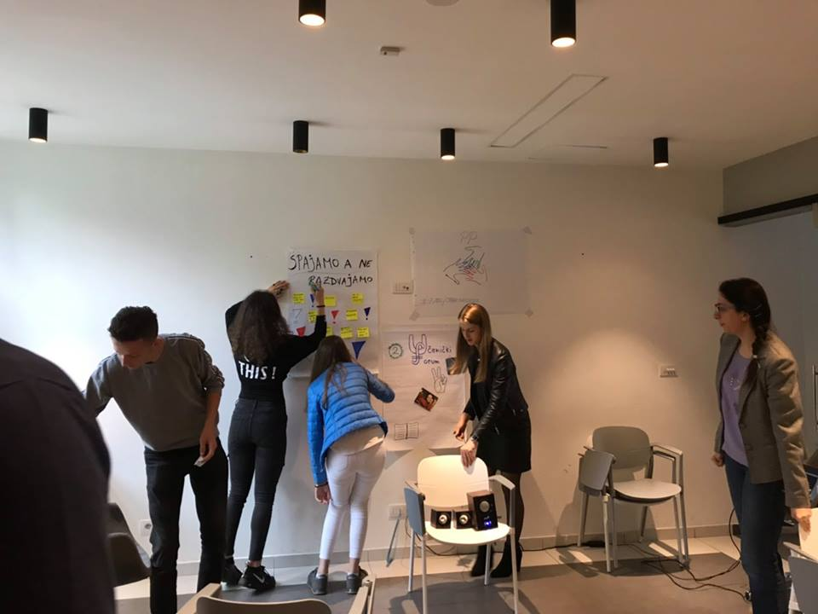

On 17th June, just after the school year has ended, a presentation of projects’ results was organised. Participants presented their accomplishments to other teams, their trainers, and representatives of U.S. Embassy and Fund for active citizenship.
The project yielded great results. Each participant got to develop team work, communication, cooperation and organisation skills. Backed up by their trainers, they were provided with a way to implement their own ideas into their schools, hence improving the terms they were studying in.

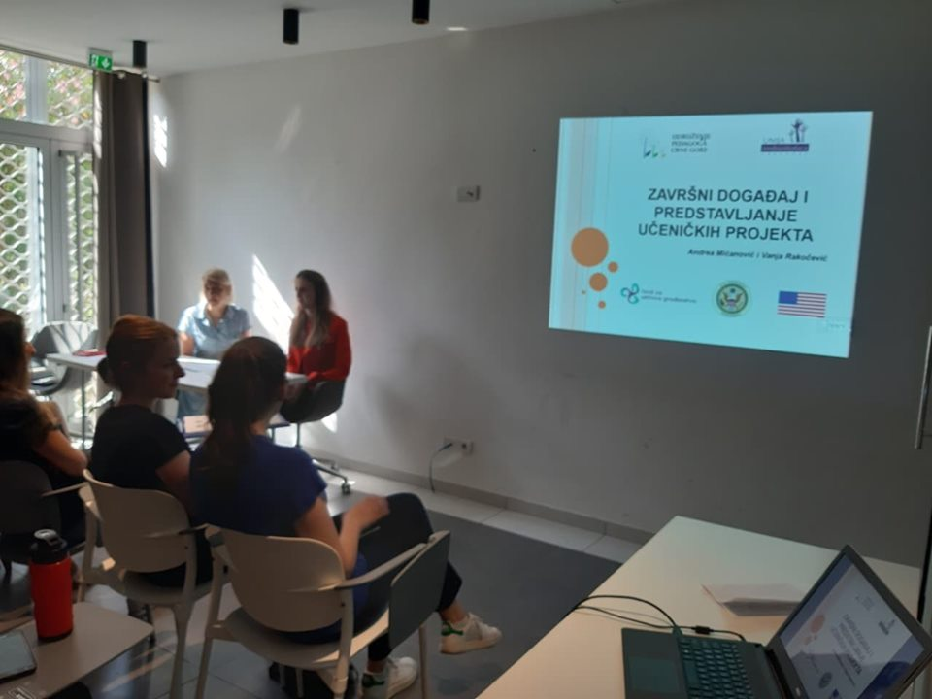

The successful realisation of every funded project once more proves that young people can do amazing things and are worth investing in.

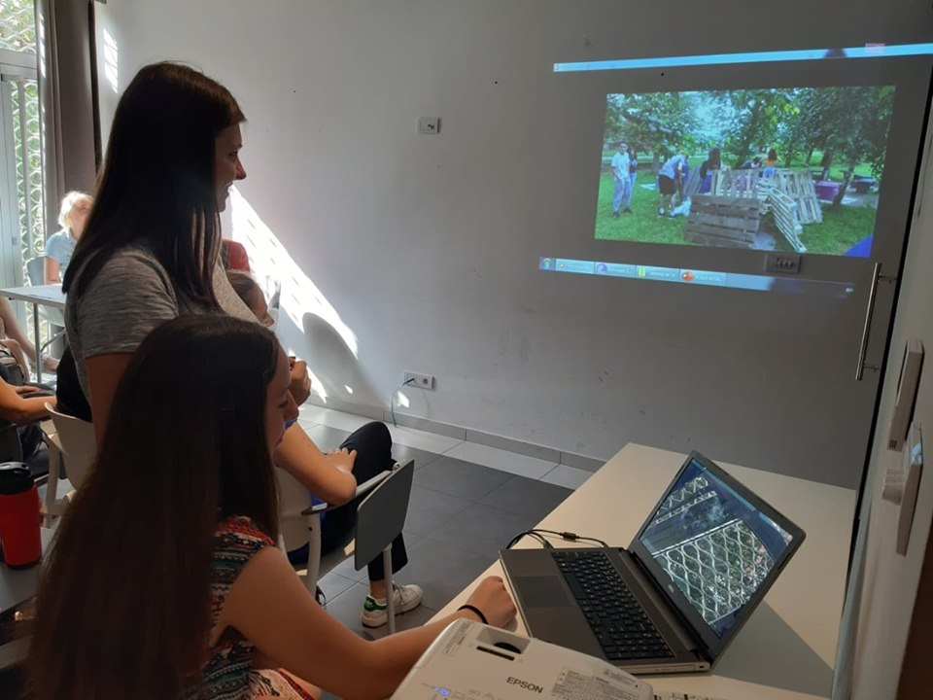

- PROJECTS

Coordination of Youth Center

UNSCG coordinates the Youth Center for a year and a half. Coordination project is financed by UNICEF. Activities relate to daily assistance to visitors to the center, making interactive workshops, organizing preparation for graduation exams in the period of them. The aim of this project is to raise awareness among young people about activism, to provide a variety of ways to spent their free time, raise awareness about volunteering and youth activism.

V General Assembly

Fifth General Assembly (GA) of UNSCG took place on 1st to 3rd November 2019 in hotel Aleksandar, Budva. 87 delegates participated on the Assembly.
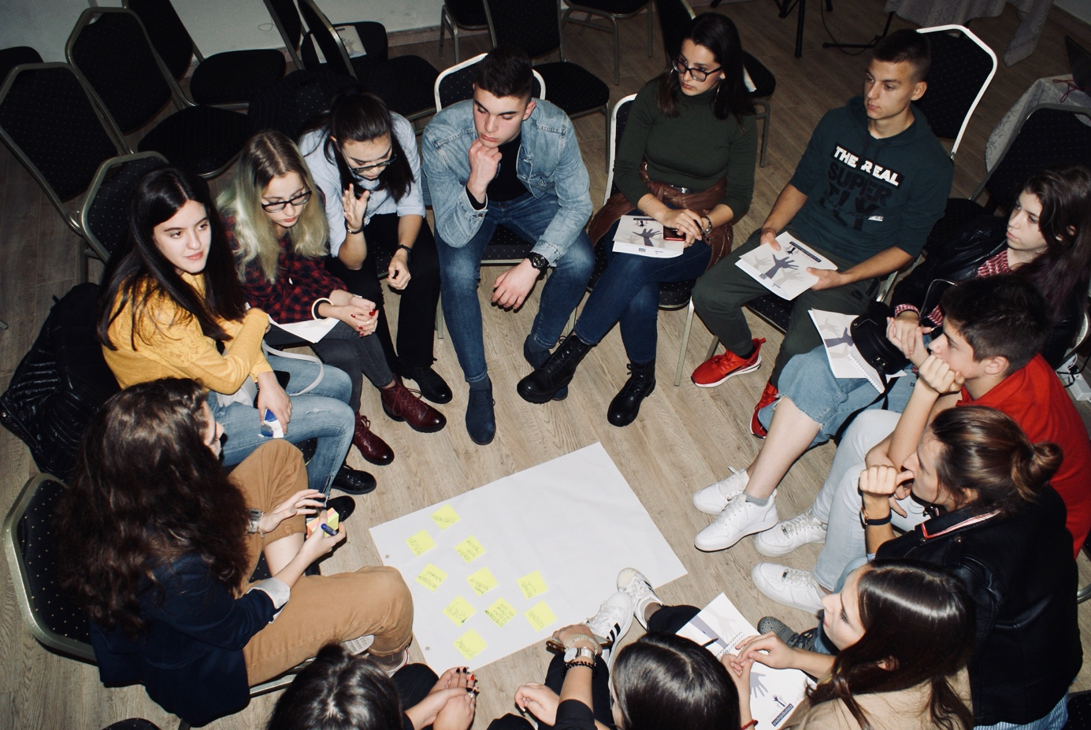

First day of the GA was highlighted by introduction of delegates that applied for positions in Administrative board and presentation of finished projects. Supervisory board presented its report to the members of the Union. The presentation was followed by an introduction of guest organisations (NGO “Juventas”, ASUBIH, SAME, and NGO “Seanema film festival”).
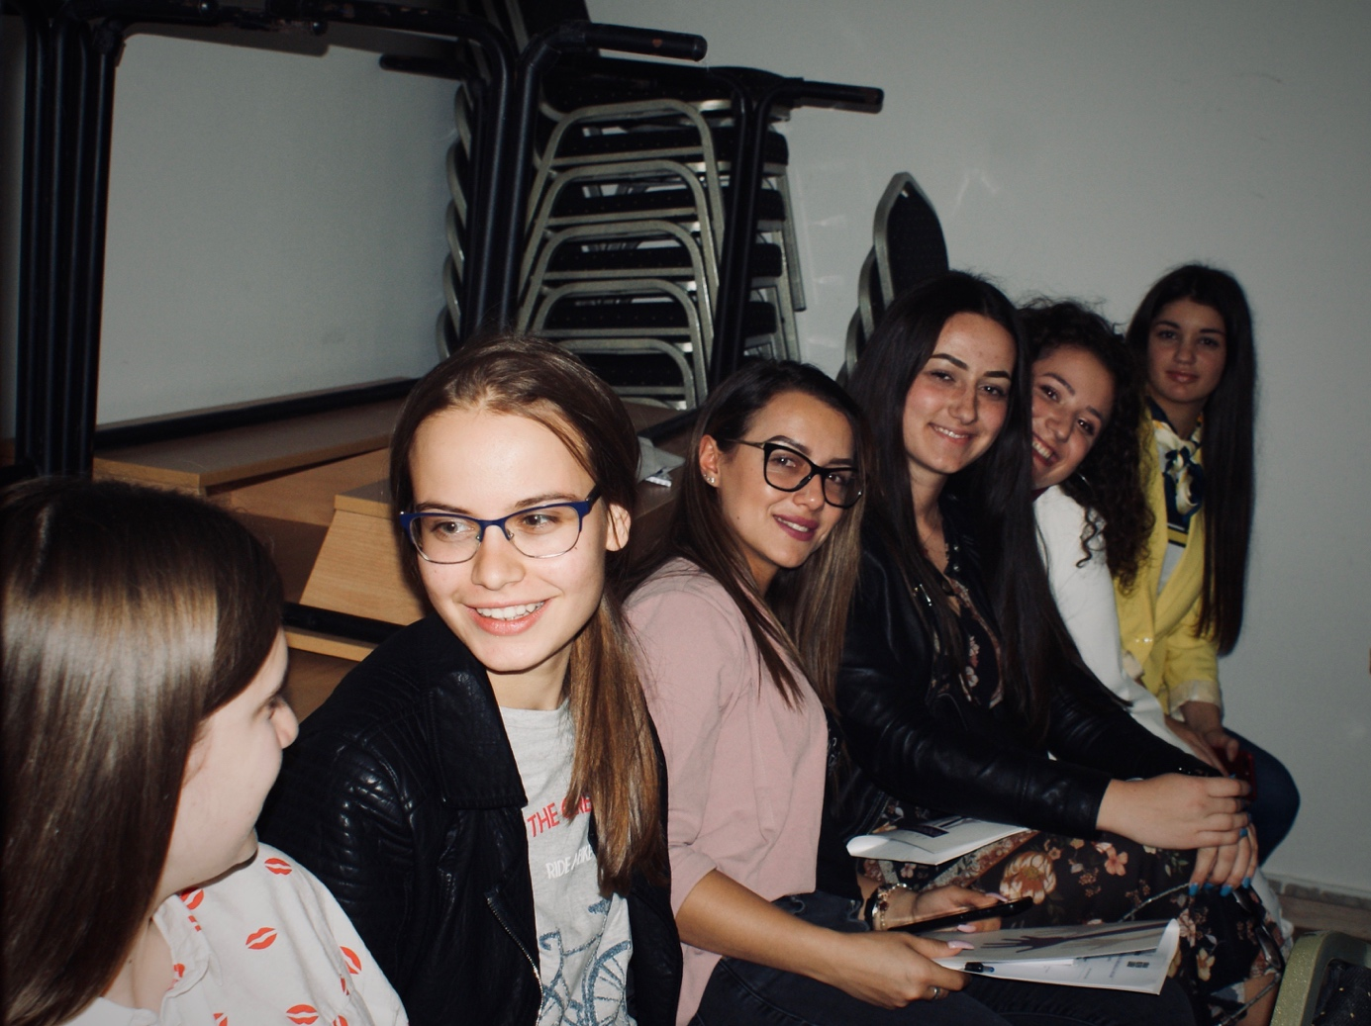

Second day was filled with workshops. It was opened with an energiser, followed by work in groups focused on strategic planning of the Organisation. Members had constructive conversations on topics that are relevant to high school students and topics that they wish were covered by projects in the future. In a second workshop special focus was put on Action day: things that should be improved, things that should be kept and plans on how to make Action day even better in 2020. After the Action day workshop, delegates had a discussion regarding problems student parliaments encounter in their work and how to solve them. The day was closed by voting for new members of the Board.
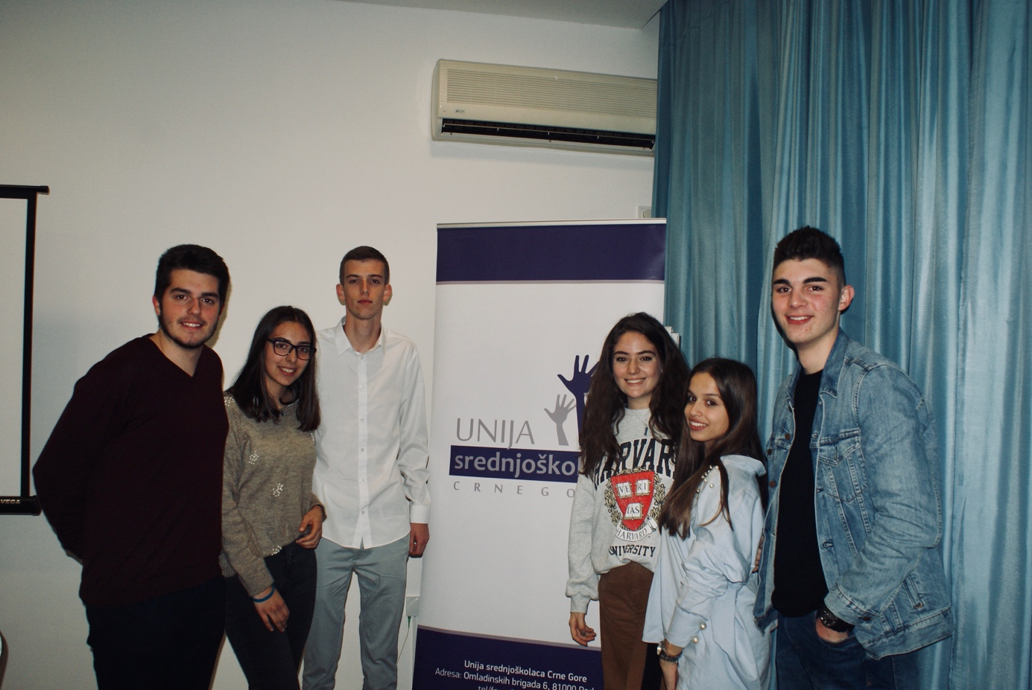

Third and the last day of the GA was spent on summing up and evaluation. To sum it up, one of our new members described her experience on the Assembly: “I was given hope that I am, as a high school student, indeed an important part of our society, and it makes me extremely happy. Meeting all those young enthusiasts at one place was inspiring”.

Dialogue days: let’s talk about future
Two members of High School Student Union of Montenegro participated in a national event “Dani dijaloga: razgovarajmo o buducnosti” (“Dialogue days: let’s talk about future”) that was part of an international event “Dialogue for the future” which was organised by UNDP on 2nd and 3rd October 2019.
The participants of the two-day dialogue come from all social spheres, including adolescents and young people, women activists and civil society organizations dealing with gender equality, media, teachers, representatives of national and local institutions, non-governmental organizations, private sector, academia, international organizations, interested citizens, experts etc.
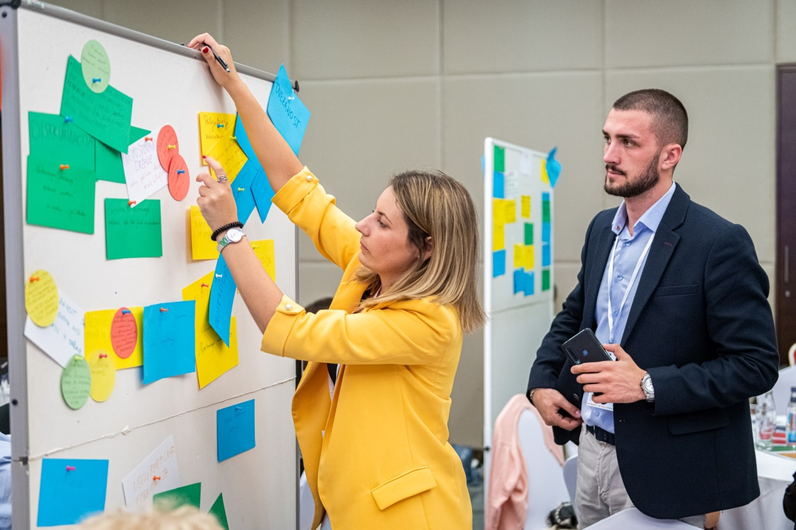
This event was especially important to the Union because it covered topic that are important to the organisation, such as the rule of law, youth activism, social cohesion etc. Participants worked together in groups to define problems that they detect in society they live in. On the second day of the event the groups met once more to discuss solutions. Similar events were held in the region on national level. A special report was made using information gathered on national events and it was discussed about on a regional event hosted in Sarajevo, on which a member of UNSCG also participated. More regional events are planned in the future.
Events like this help the Union get more detailed information about the problems other organisations and people involved in youth policy encounter. It also helps in getting involved in matters that are directly linked to young people and getting voice of the youth heard.
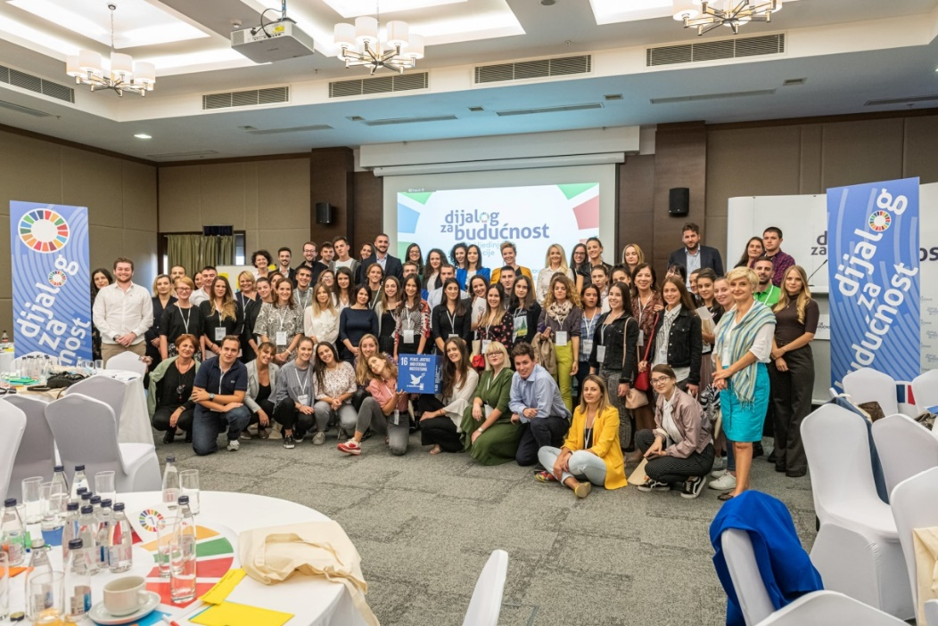

WFD Seminars

Coordinator of the south region Vladimir Perazic took part in Westminster foundation for democracy event called Academy for active cooperation of young activists from the civil sector and political parties. The first module was organized from 28th until 30th of November in hotel “Palas” in Petrovac. On the beginning participants were working in groups and try to found the main problem of young people in Montenegro. The task for the groups was to make a panel discussion with young people to have a feedback, after that it will be organized the second module to continue with work(January 2020). Name of the second module is “Collaboration and team” so the participants will focuse on that two things. Until the end of the year WFD will organize two more modules and at the end it will be organized event where the participants will present results of the whole process.

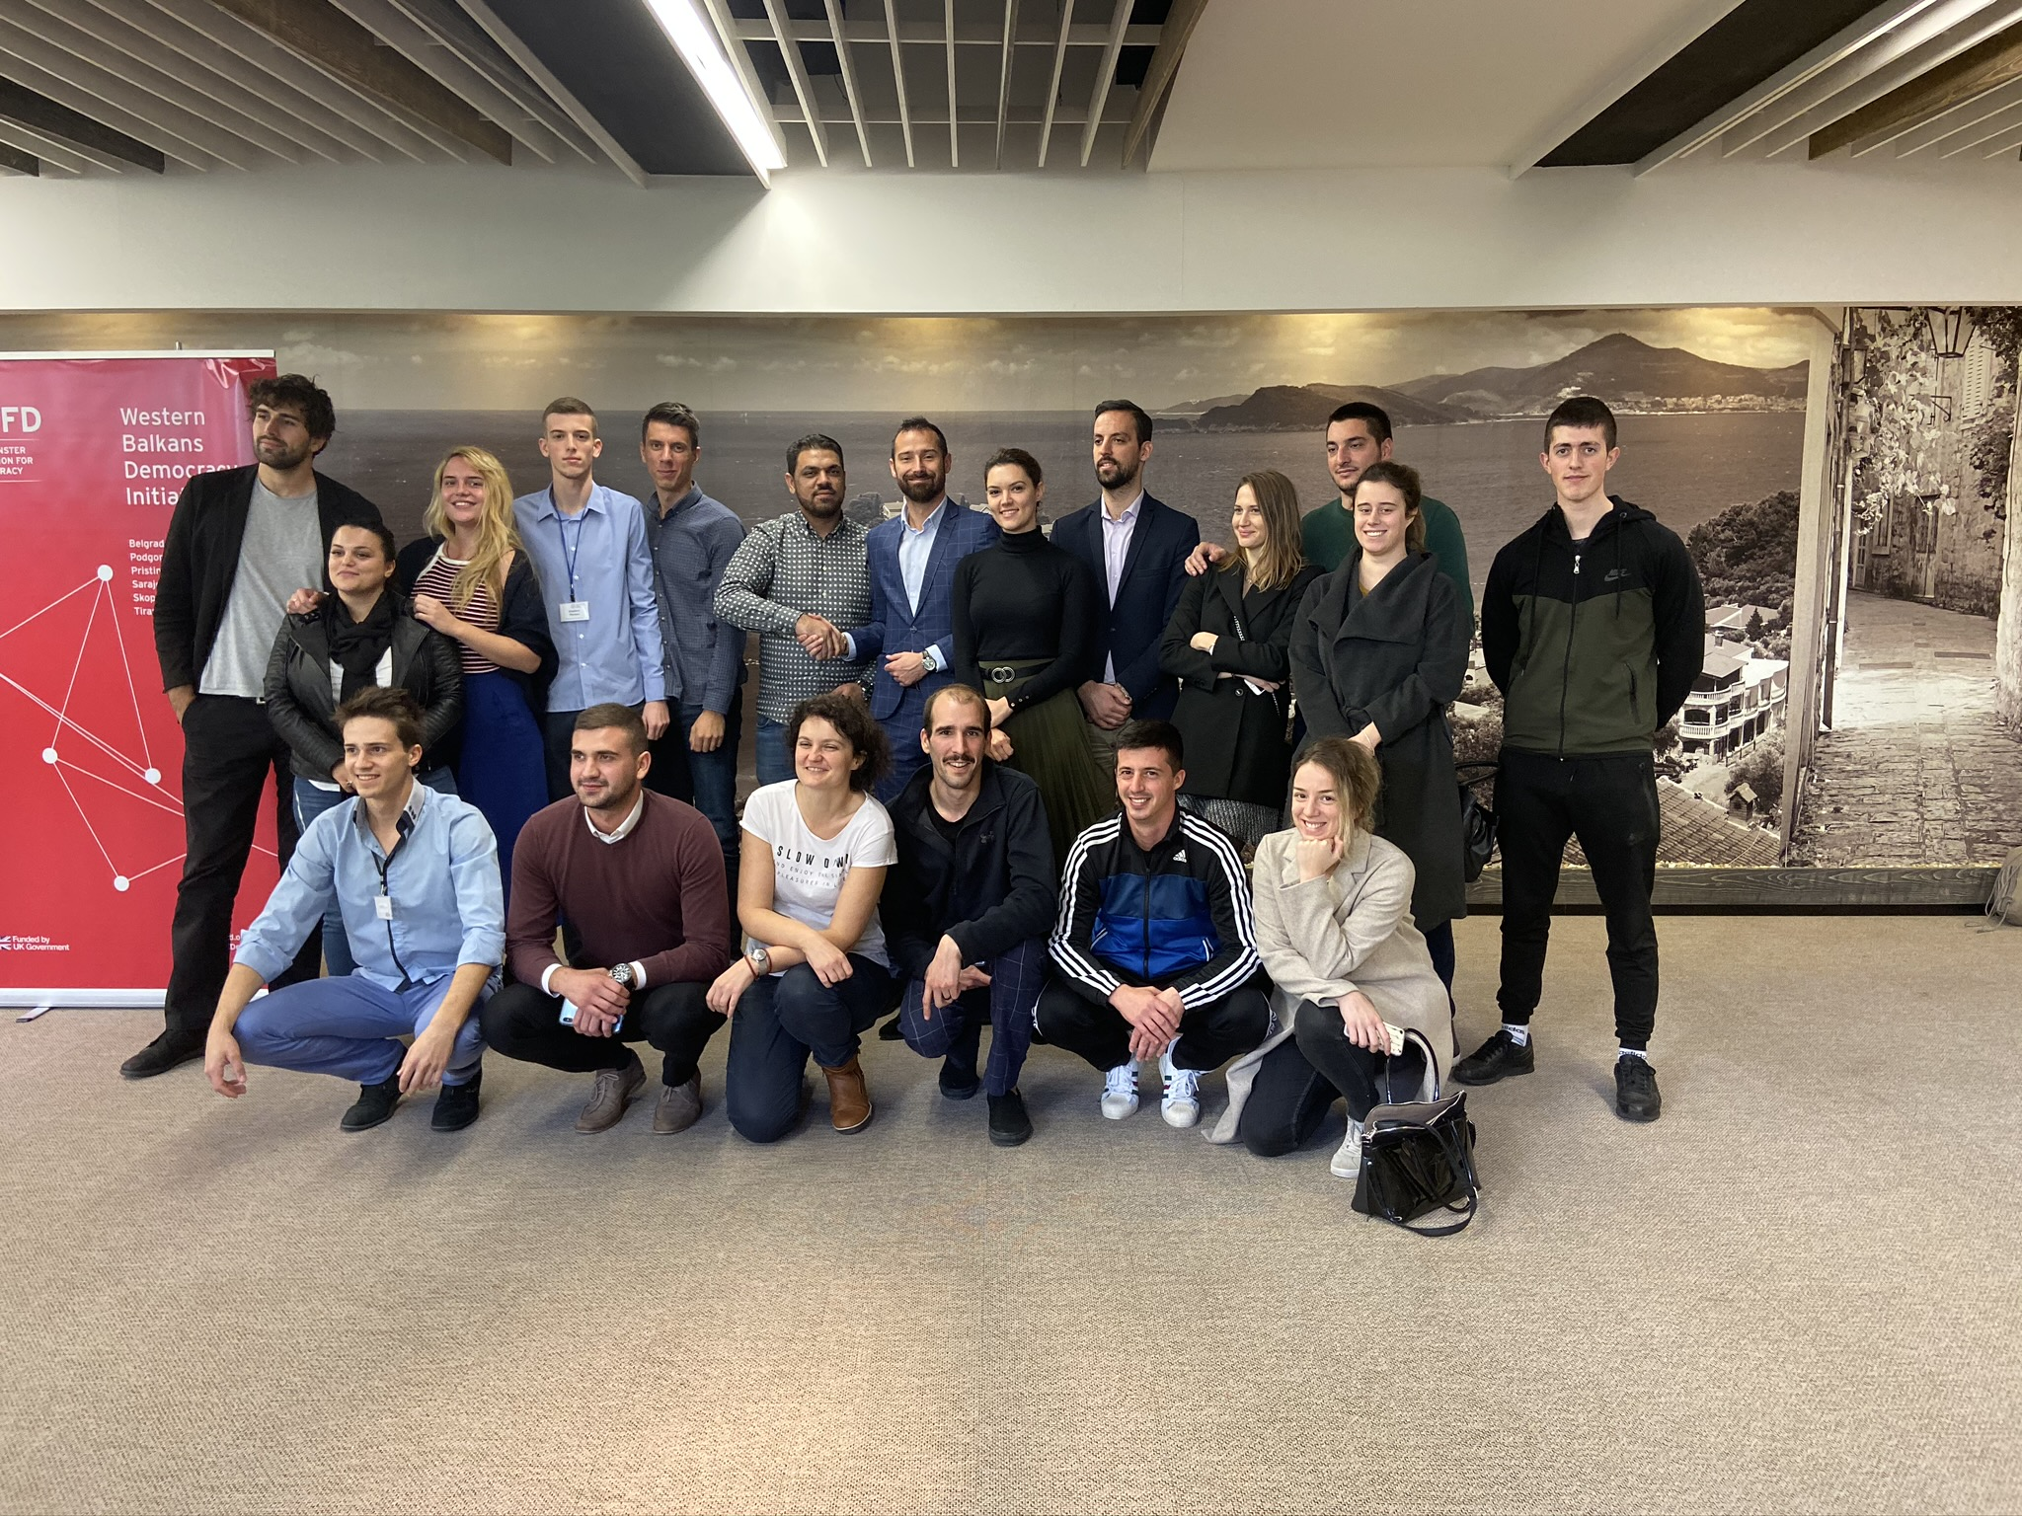

FES Seminar in Skopje

Our delegate Vladimir Perazic, participated in a seminar organized from 30th of May until 2nd of June, in Skopje, North Macedonia. Organised by FES (Friedrich Ebert Stiftung Prishtina office), that was a second seminar and it was focused on forming a new legal body called Western Balkan Youth Voice. On the meeting we determined our mission and it aims to create a unified voice of youth representation bodies in the
region through interconnecting youth structures and jointly working on a common agenda resolving problems faced by youth in the region (Serbia, Montenegro,Kosovo, Bosnia and Herzegovina, Croatia and Macedonia). During the seminar, participants made a plan of activities for next six months.
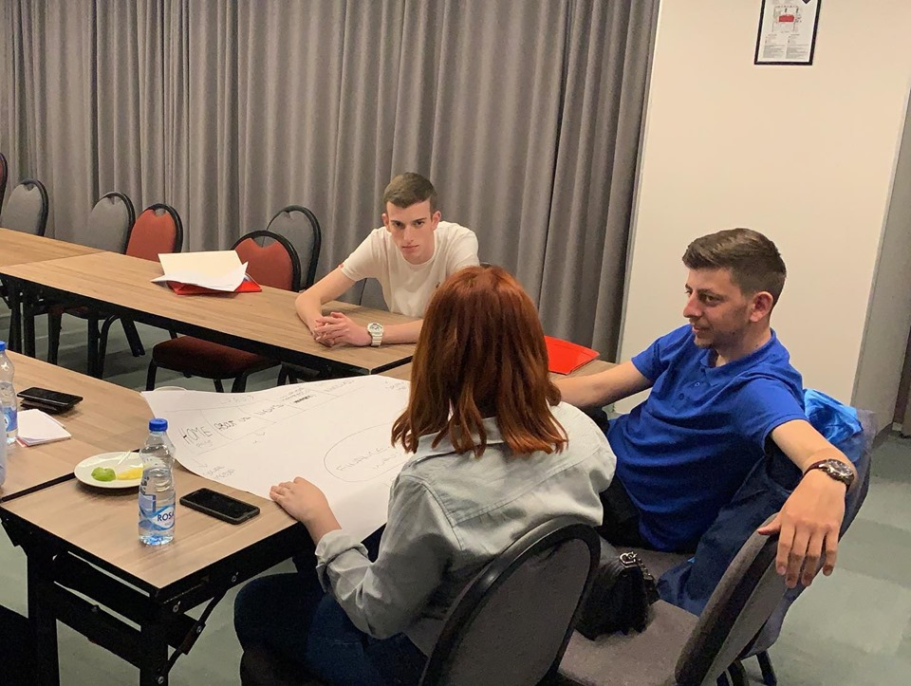

4th Youth Regional Forum

In the beggining of October, President of the Assembly, Danilo Popovic; Secretary of the Assembly, Milica Miranovic and Coordinator of central region, Balsa Bozovic were presenting UNSCG in Regional Youth Forum in Novi Sad.

At 3 days of Forum, they had chance to talk about Law on youth in Balkans, problems and specific data based in every country in region.
The three-day Forum concluded with a panel discussion on the Western Balkans in 2030 – Visions, Wishes, Realities, attended by the RYCO Secretary General Mr Đuro Blanuša, the prime ministers of Serbia and North Macedonia Ms Ana Brnabić and Mr Zoran Zaev, and the Regional Cooperation Council Deputy Secretary General Ms Tanja Miščević. The forum gathered around 200 young opinionated leaders and policy-makers to discuss regional salient topics and challenges.
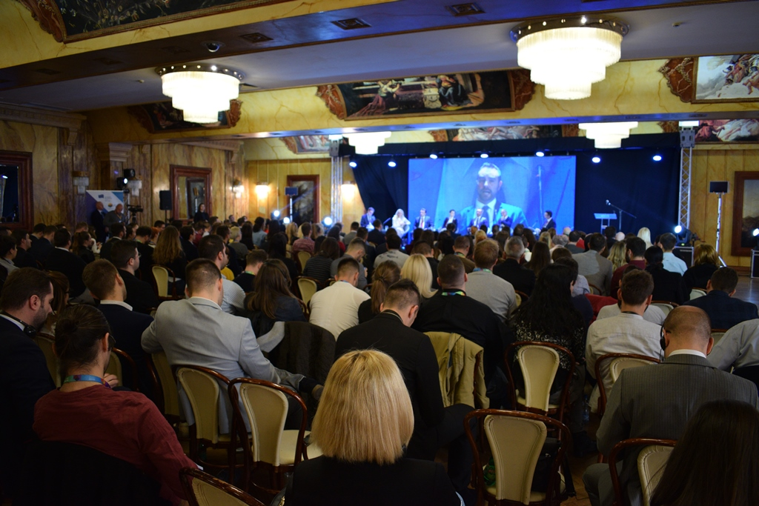

The Regional Youth Forum was organized by the European Movement in Serbia – local branch Novi Sad and the Belgrade Fund for Political Excellence. Indispensable support was provided by the Provincial Government of Vojvodina, the City of Novi Sad, the Regional Cooperation Council, the Regional Youth Cooperation Office (RYCO), the Polish presidency of the Berlin Process and the Deutsche Gesellschaft für internationale Zusammenarbeit (GIZ) – ORF Promotion of EU Integration.

Conference against violence

Our Board president, Varja Vukcevic, attended a coference in PR Center Podgorica, and was invited to openly speak about violence against transsexual children in high schools.
During her speak, she promoted that we everyone should always pay attention to human qualities, before anything else – such as sexual or national choice.
On that day, hosts of the event introduced everyone present, to the research they have done in previous year. Its main topic covered the issues transsexual people face during their schooling and everyday life.
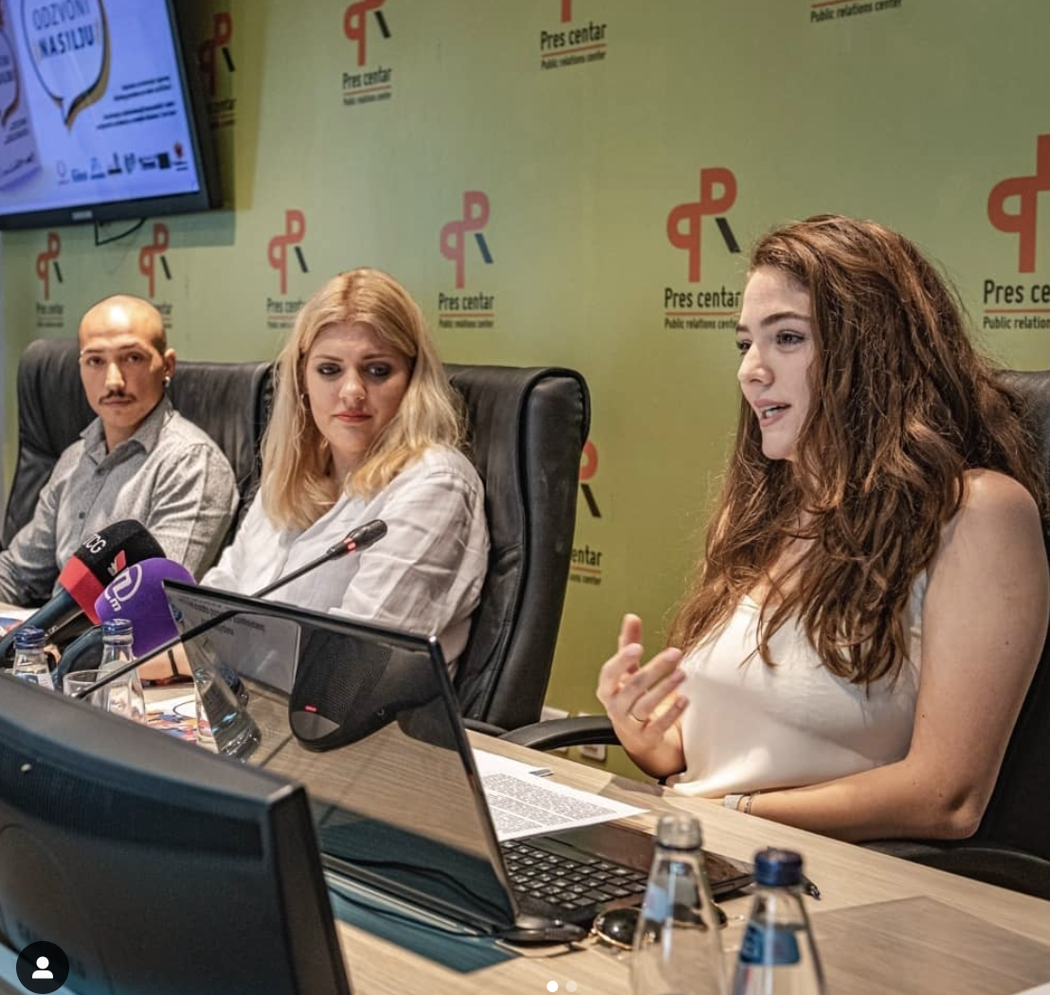

We believe that it is very important to promote equal rights for everyone, which was exactly the point Varja highlighted in her speech. She was asked questions about what Union does to try prevent and potentially solve this major problem, which she answered directly.
“This is the problem which should concern all of us. When every single relevant institution, organization or group put effort into solving this issue, it becomes easier. Until then, we weill continue to raise awereness through panel discussions, gatherings and different workshops.”

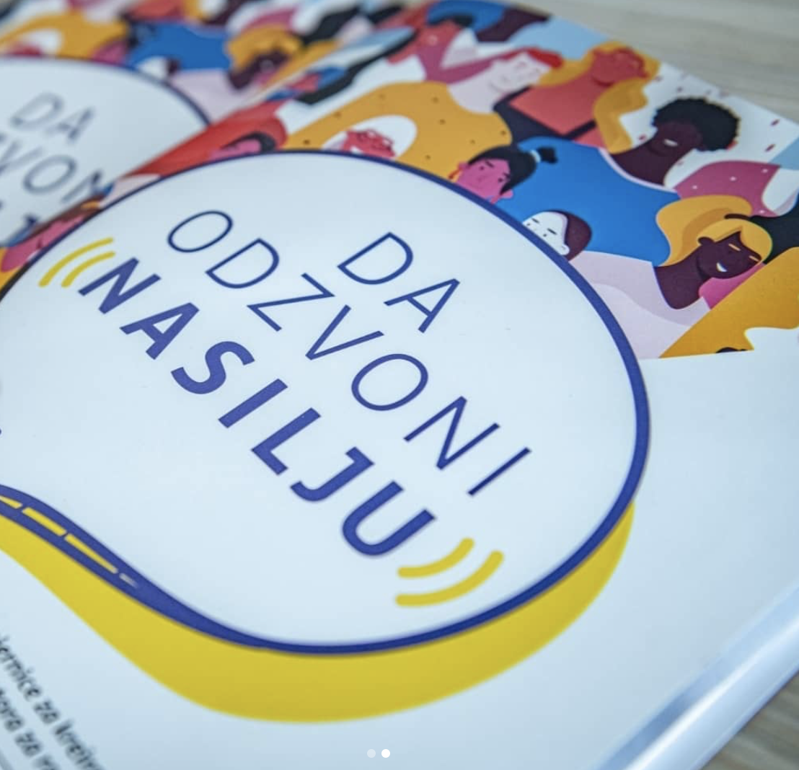

Youth Day - Workshop – Stereotypes and Prejudices

Our presidents – both from the Board and from the Assembly – Varja Vukcevic and Danilo Popovic, alongside former president Andrea Micanovic held an interesting workshop which connected tabu topics of stereotypes and prejudices with young people, on 12th of August, in Cetinje.
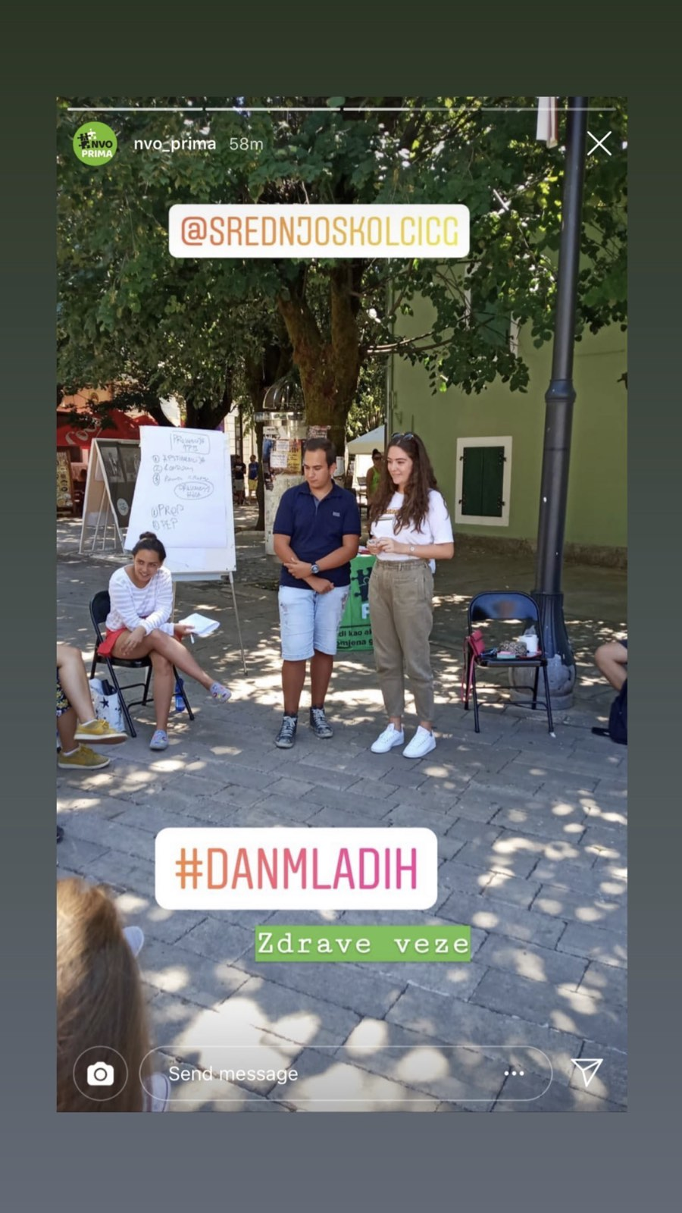

In front of about twenty high school students from different parts of Montenegro, they did an interesting workshop, which encouraged young people to talk about this, and even present some of their own examples. The workshop lasted for about an hour, after which we gathered the feedback from them, in order to make those kinds of workshops even more successful.

Youth Connectivity Forum 2019

Our presidents – both from the Board and from the Assembly – Varja Vukcevic and Danilo Popovic, where invited to attend the fifth WBYCP Forum in Tirana, Albania, from 29-31th of October.

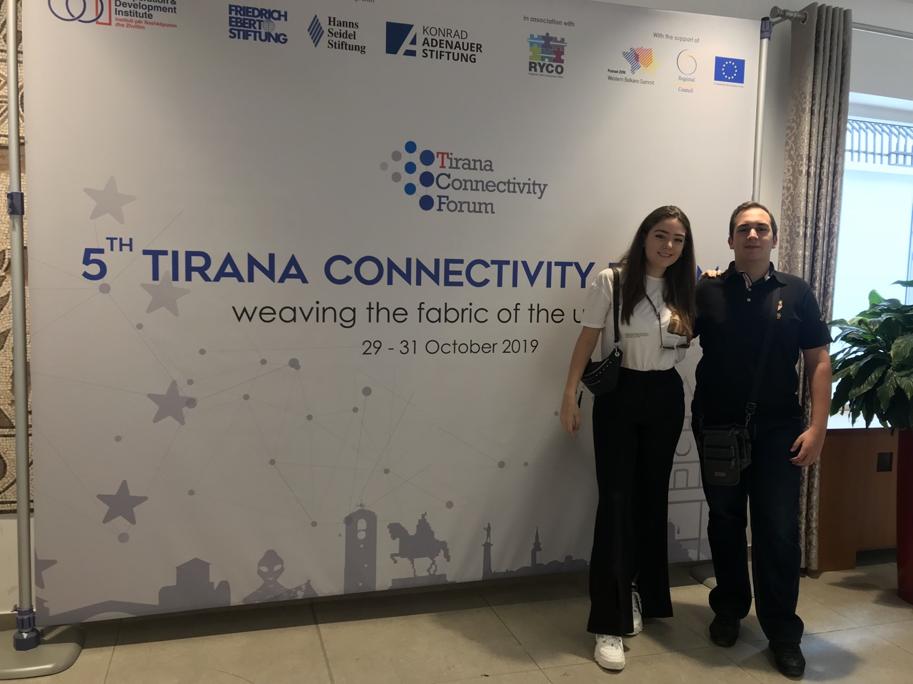
At the very beginning, UNSCG presented itself as an organization to civil society, academia and public institutions. The report ‘Youth and Non-formal Education – Guidelines for further development “ realized in cooperation with Cooperation and Developed Institue and with the support of HSS. This report reveals that Montenegrin youngsters are asking for:
- A better link between formal and non-formal education system
- More awerness of school staff on the importance of non-formal education
- Encouragement for participation that non-formal education provides
- More support to youth clubs
- Institutionalization of non-formal education
- More campaigns on raising awareness of parents of the importance of non-formal education

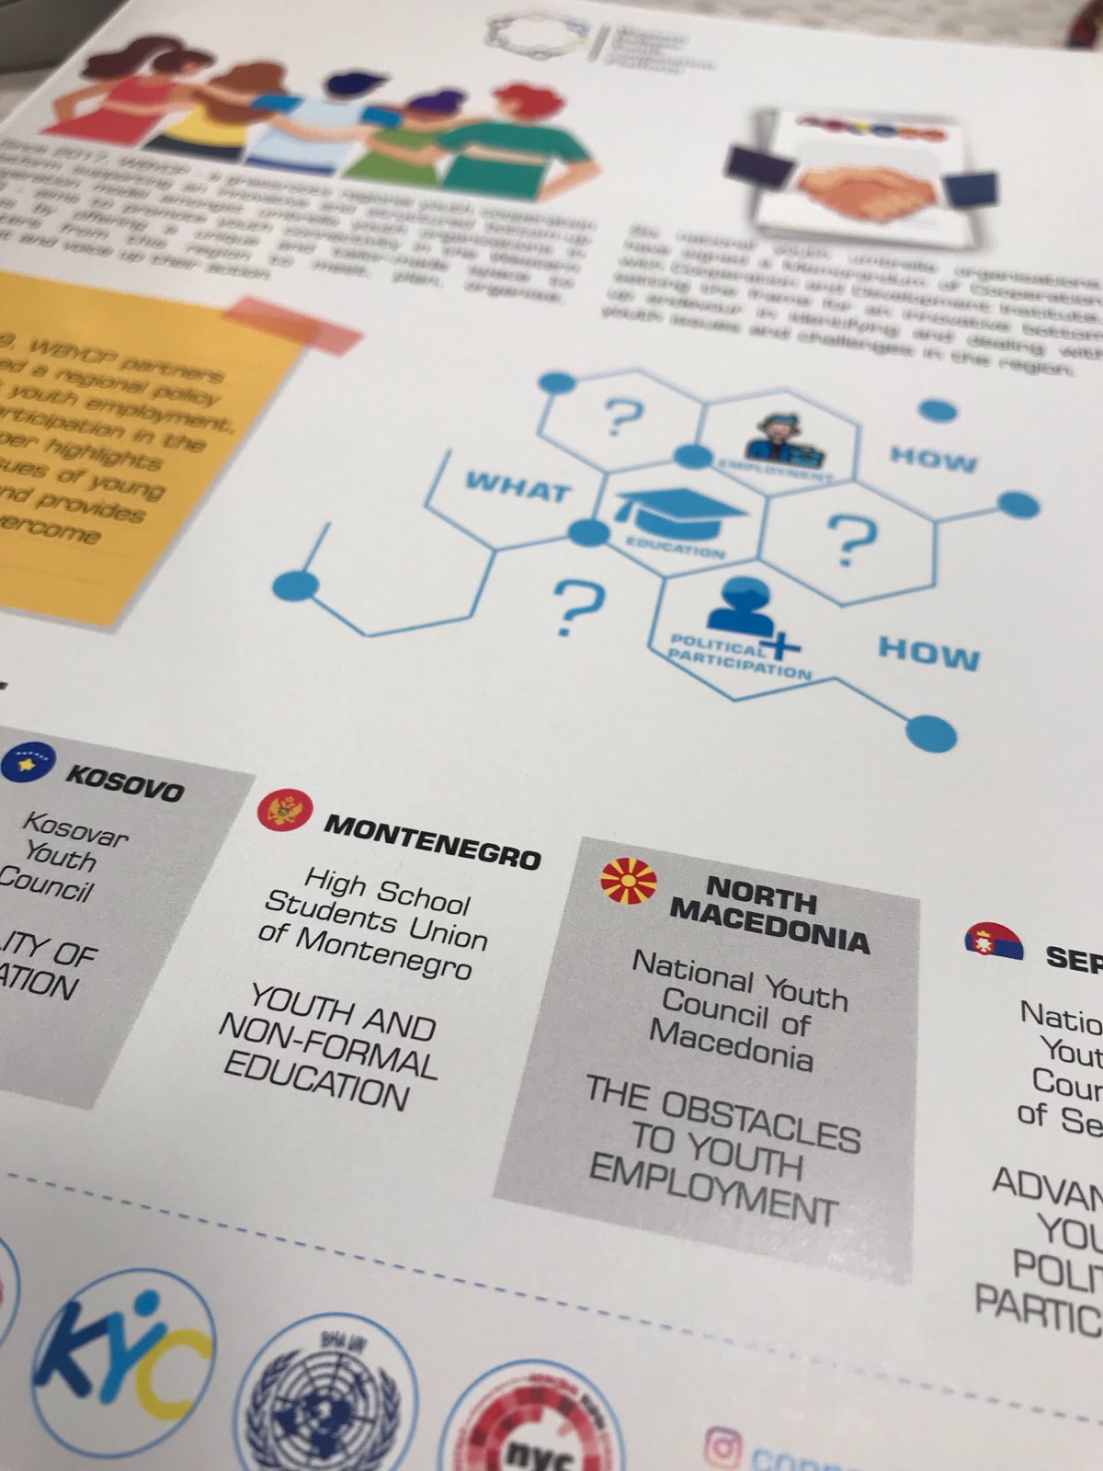

During these three days, Varja and Danilo had a chance to talk about Youth challenges and digital economy, and how is this burning question developing in 6 Western Balkans countries. On 30th of October, they visited panel discussion, where they were able to interact with the speakers but also ask questions about interested points of their speeches.
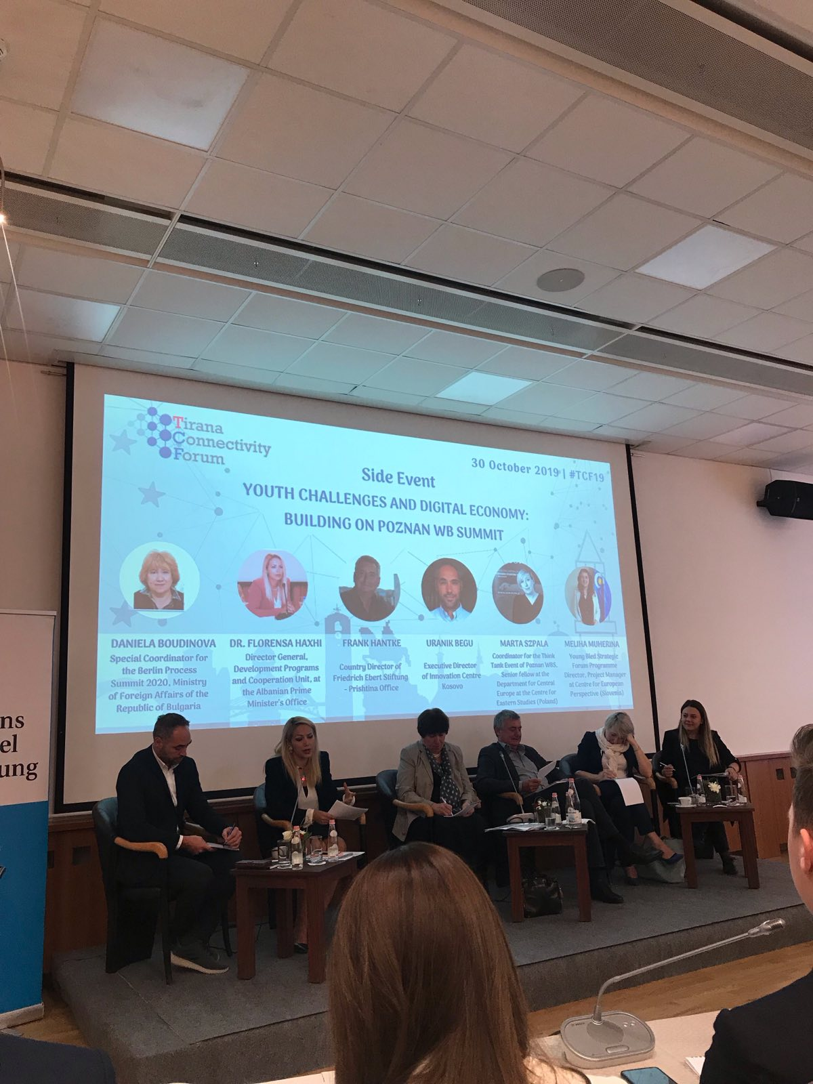

School visits
Northern region coordinator, Bojana Ralević, who became a member of the board of directors at the General Assembly in November 2019, attended a session of the Student Parliament at Pljevlja High School, Gymnasium „Tanasije Pejatovic“, on November 11th. Bojana expressed her satisfaction with the very good cooperation with the students parliament of that school, but together with the delegate from that school, the coordinator and the members of parliament she talked about what they can improve in future cooperation. Parliament was also attended by a representative of the school administration.
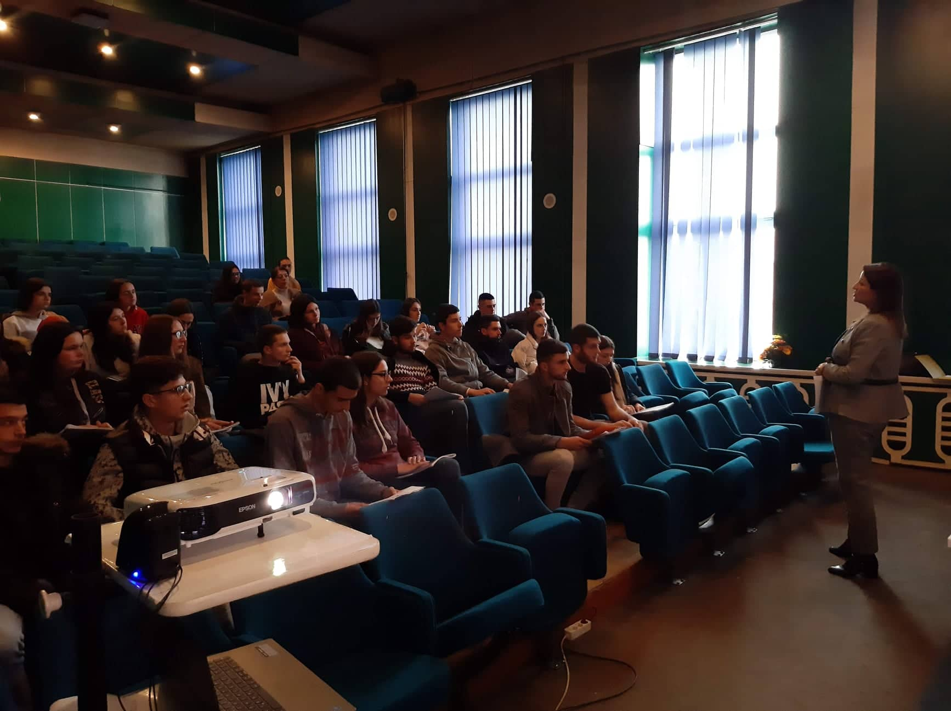

Summer Assembly 2019

OMSA

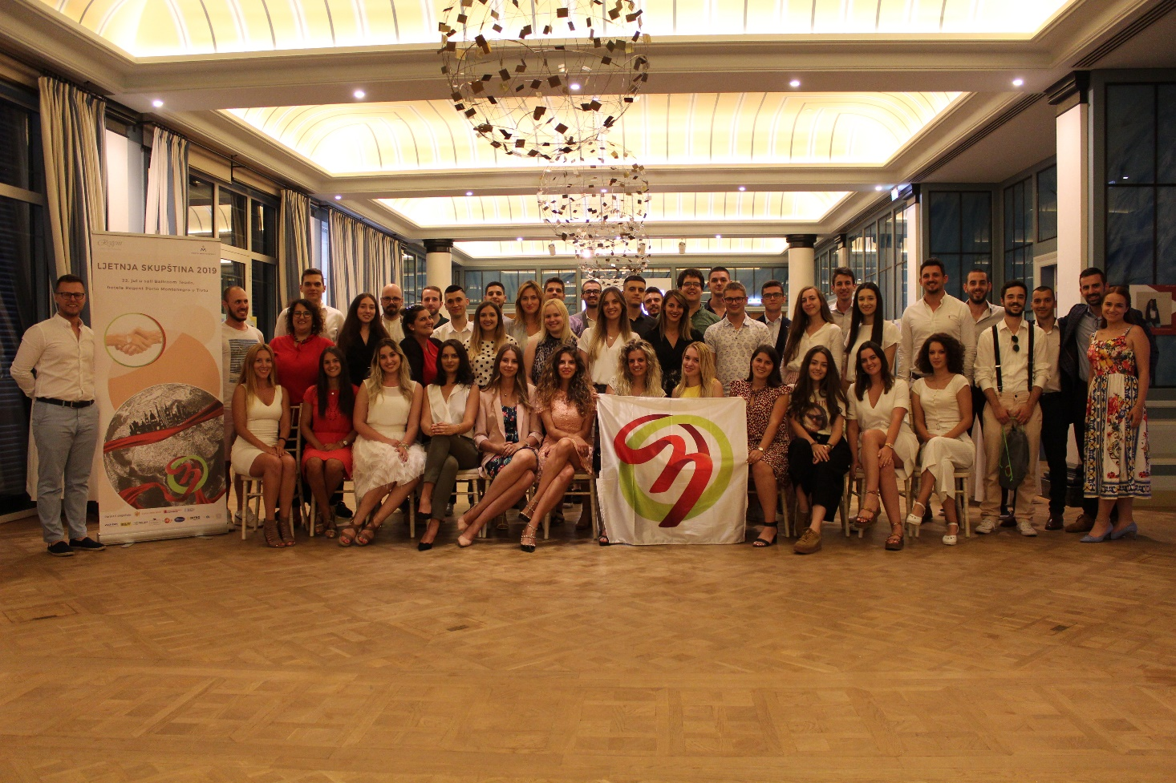
Hotel Regent, Tivat - 23th of July 2019
Our president Varja Vukcevic had a chance to be a part of OMSA’s Summer Assembly and to present UNSCG in the best way possible. With all the Montenegrin students who are studying abroad, she exchanged experience and talked about their future activities and possible cooperation between OMSA and UNSCG.

UNSCG presentation
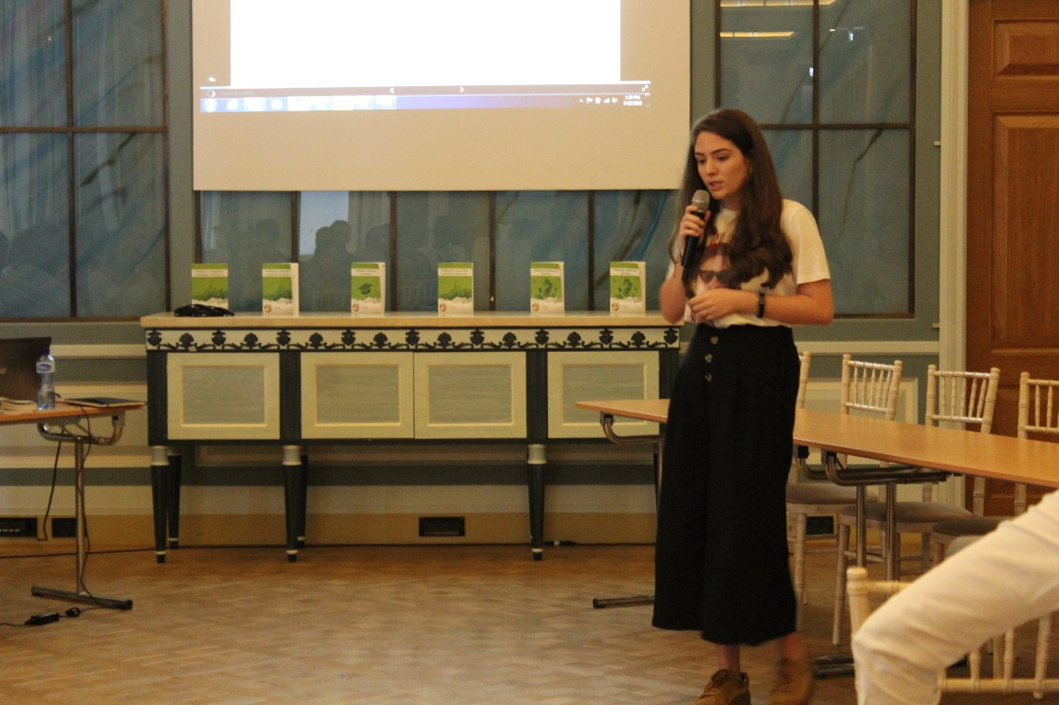
During 10 minutes, which were planned for organisation presentations, Varja made sure to clarify the structure, activities and vision of UNSCG. She talked about the Board of directors, Assembly and General Secretary.

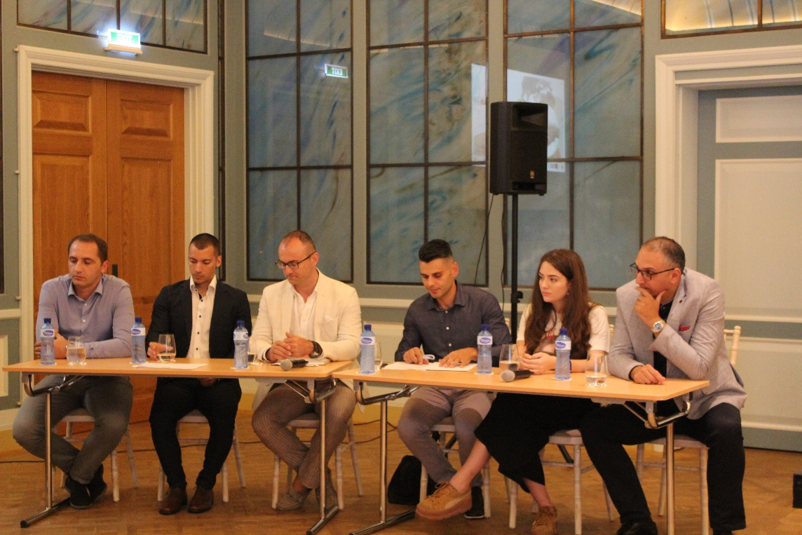
Panel discussion
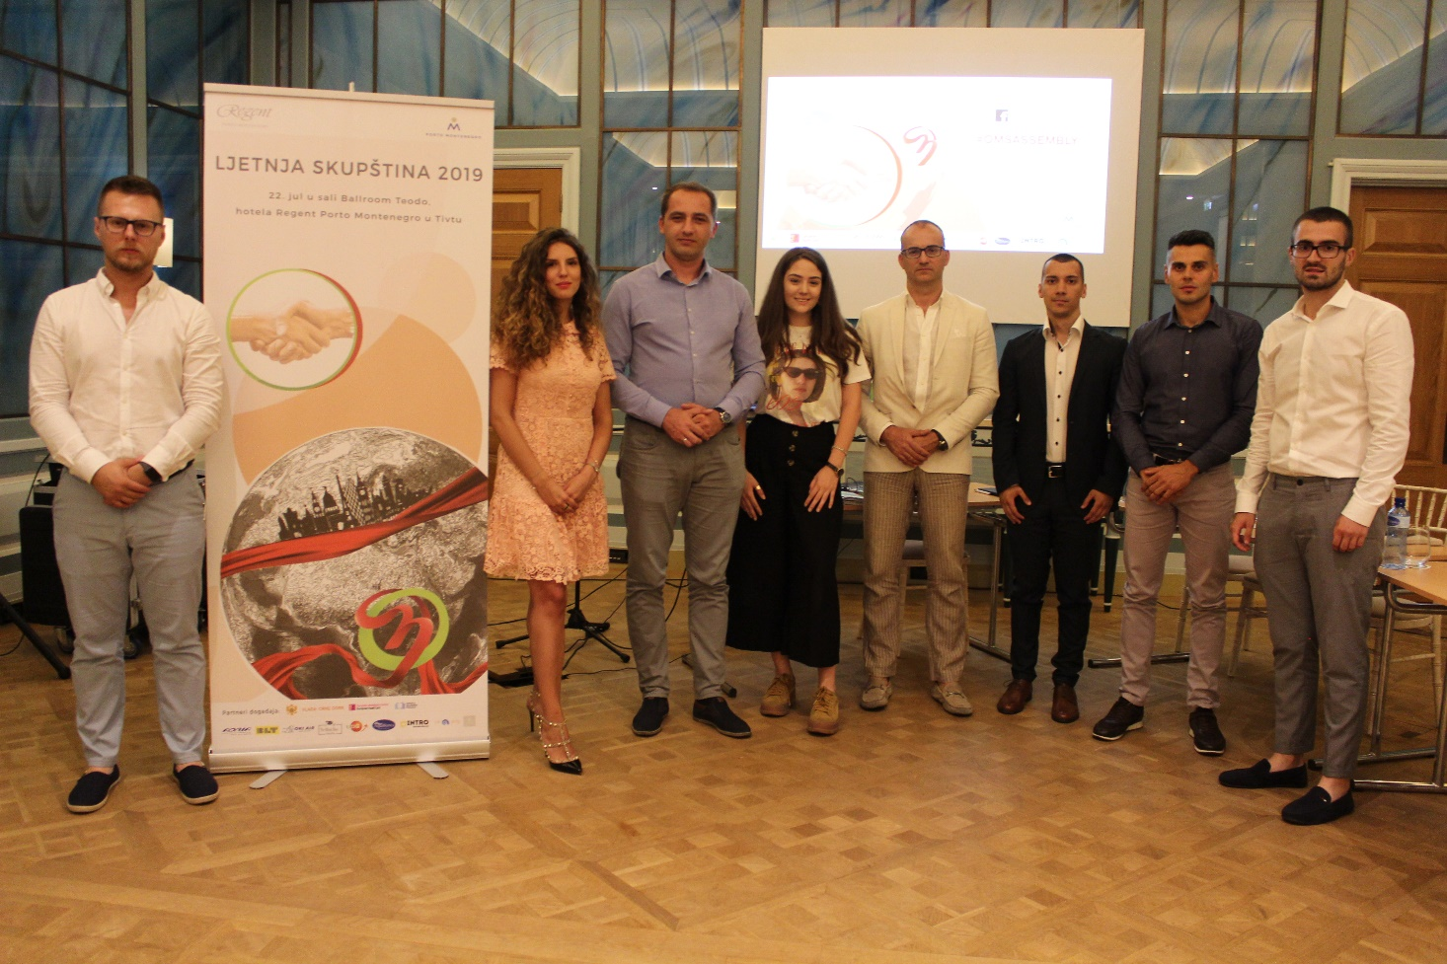
Another thing which was present on our timetable was the panel discussion concerning adjustment of Montenegrian students abroad. Besides Varja, there were five more panelists, both presenters of Government and NGOs. Varja talked from a high school student perspective and mention some of the scholarships which are the most popular ones in Montenegro.
She noticed that high school students are not well-informed about all the possibilities that are waiting for them abroad. As an organisation, we received some of the suggestions, we will happily apply in future.

Improving Media Literacy in Montenegro
On 19th November 2019, PR Manager Jelena Dobricanin spoke at the conference "Improving Media Literacy in Montenegro", at a panel on the role of the education system in promoting and developing media literacy. The aim of the conference is to open a discussion about media literacy and the education system, as well as the role and responsibility of the media when it comes to this skill.
During the presentation, the problem of spreading false information through the media was highlighted, as well as a great deal of uneducated and uninformed youth about this topic. Young people today are constantly exposed to the media in all kinds, and it is imperative that, with adequate knowledge, they are able to recognize what is good and not good for them when it comes to media content. The problem is recognized by the fact that media literacy is studied only in Grammar schools as an optional subject, which is not only discriminatory against other high school students who do not go to Grammar shools, but it is also less than satisfactory that media literacy is not recognized as a regular subject, which we believe that it should be. It is hoped that high schools across Montenegro will take this topic much more seriously than in the previous period.

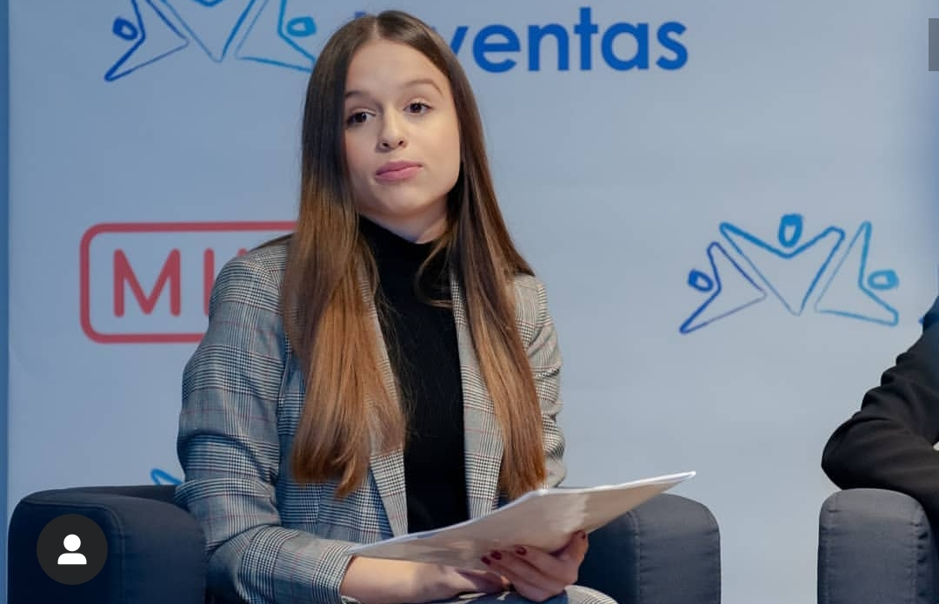
SAME Summer Academy in Lübeck
SAME Summer Academy in Lübeck was definitely one of the more significant events we had this year. During the residency period, UNSCG was given the opportunity to become a full member of SAME, which is a great honor for us. In addition, we had the opportunity to see how other organizations similar to ours do with a focus on Action Day. Therefore, we learned how to improve our work and how to generally improve the organization itself. Our days were filled with many interesting workshops, we presented our country and organization to others, dealt with interesting and important topics but we also had a lot of free time during which we were able to get to know other participants better.
In addition to the formal part, we were able to meet many new people - different nationalities, religion, skin color, sexuality .... Therefore, to make many friendships. We hope that our cooperation with SAME will be even stronger and that we will visit their events more often!
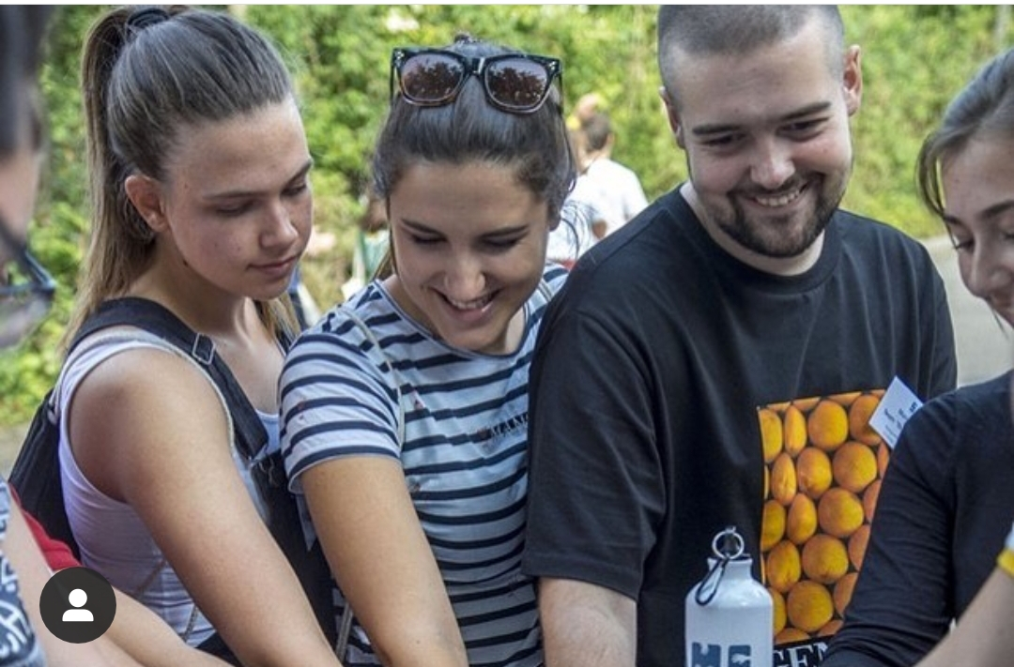

Coordinator of Central region speaking about Youth problems on TV Vijesti

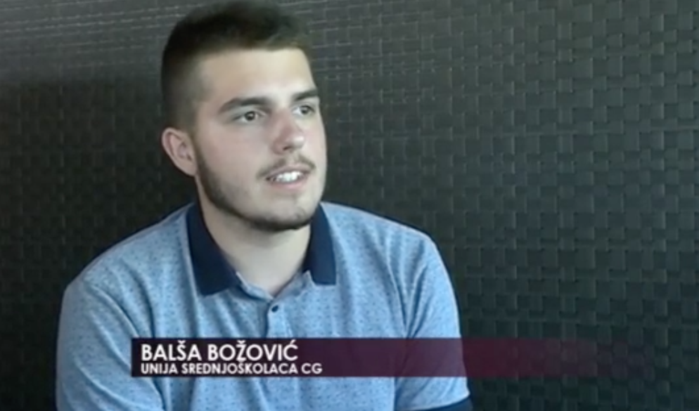
On 14th September, coordinator of central region, Balsa Bozovic spoke about problems that young people in Montenegro have been going to. Balsa emphasized that young people are a great potential of Montenegro, and that it is necessary to give them the opportunity to show their acquired knowledge. The opportunities afforded them are increasing, but not enough. As Balsa says, we must not stop at this, but must offer young people the opportunity to further improve their abilities and broaden their perspectives. We, as the Union of High School Students of Montenegro, are here to give all our high school students the opportunity to engage in high quality and active involvement in the social flows of our community, and to contribute together to all. He also added that it is important to give young people chance to get experience and try new stuff, even if they had non of it before.

SAME Summer Academy – 2019
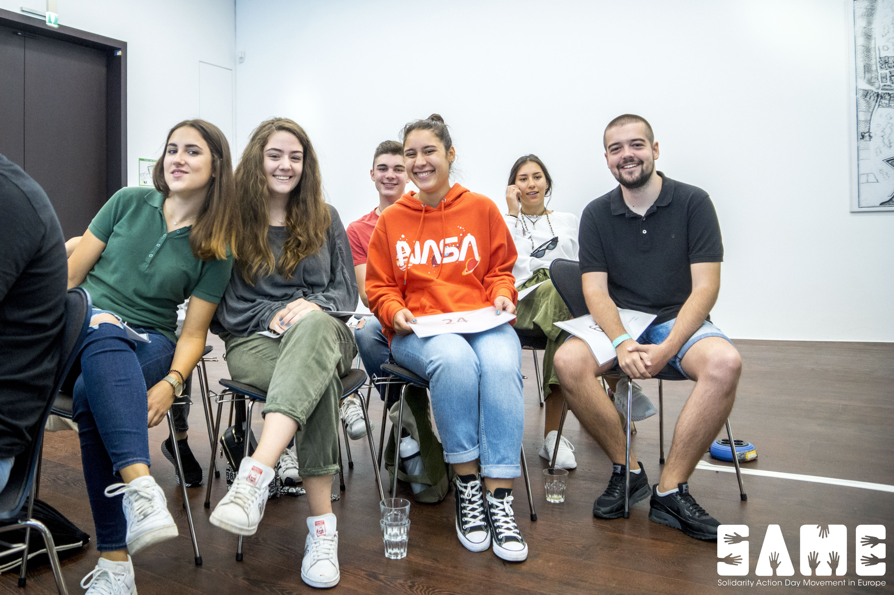
Our Delegate Konstantin Vukic, along with 4 members of the board and 3 delegates attended SAME Summer Academy that was held from 27th july to 4th august, in Lubeck – Germany. Participants of the summer academy came from various Europan youth NGO-s. Many of the participants were volunteers, social workers, activists and highschool students. During this time Every delegation had an opportunity to present the work of the following year in their organisation, in this way all the participants had a chance to exchange expiriance. Also many activites covered the implementation of the Action day in our countries wich our Organisation is doing for several years in continuity. In the “off duty” hours we had wonderful teambuilding activities and had a chance to really make a connection with people and make some long-lasting friendships. In the end of the SA, a general assembley was held where among other things our organisation, UNSCG became member of SAME.

Yuth exchange – SH4Y (Sexual health for you)
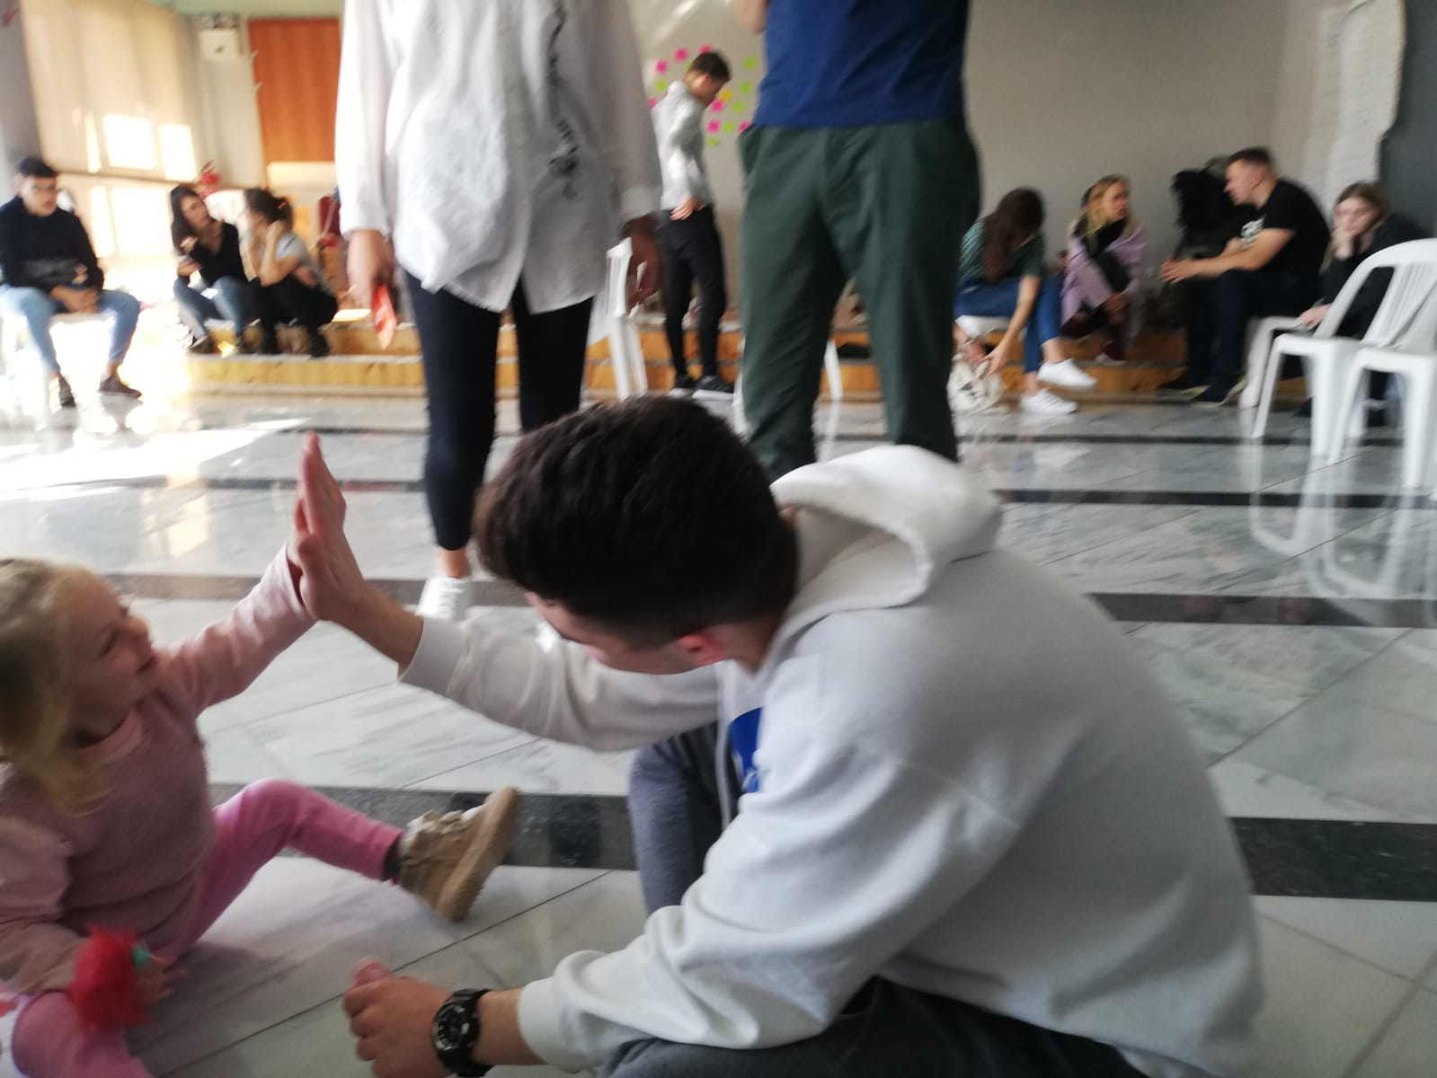
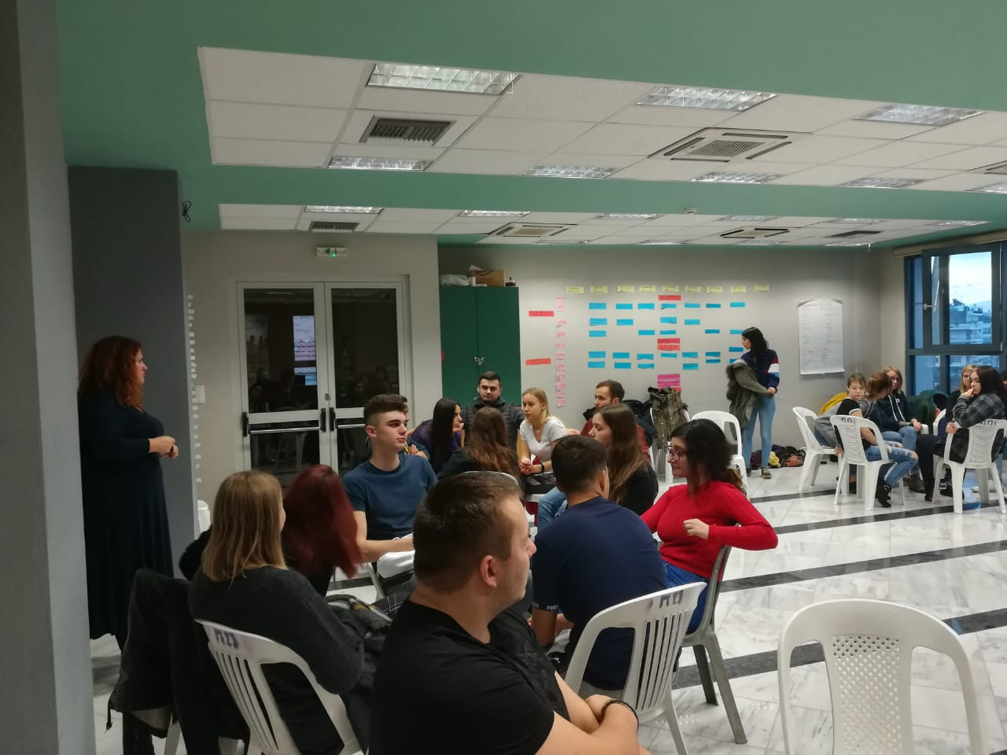
Member of the governing board for marketing and fudraising Konstantin Vukic, attended a youth exchange that was held from 24th november to 2nd december in city of Drama, Greece. During this period people from the following countries: Spain, Estonia, Lithuania, Greece, Serbia and Montenegro, attended many educative workshops on the topic of sexual health, healthy relationships and discrimination. Also there was a day for every delegation to prepare its own workshop on the same topic, this way everyone could learn from one another on how to educate people. There were also many activities wich included treasure hunt in the city and interaction with the locals. In the end of the exchamge all the praticipants recived “Erasmus Youth Pass”, and had an obligation to hold an educative wrokshop in their own countries.

High School Students Day

The day of high school students was realized on November 19 at the Youth Center in Podgorica.
A total of 43 high school students attended this day's celebration.
The activity consisted of 3 segments, namely:

Educational Panel - Student Parliaments - Problem Solving and Efficiency (5pm to 6pm)

panel - media literacy from the perspective of adolescents (18: 20h - 19: 30h)

projection of the Joker movie

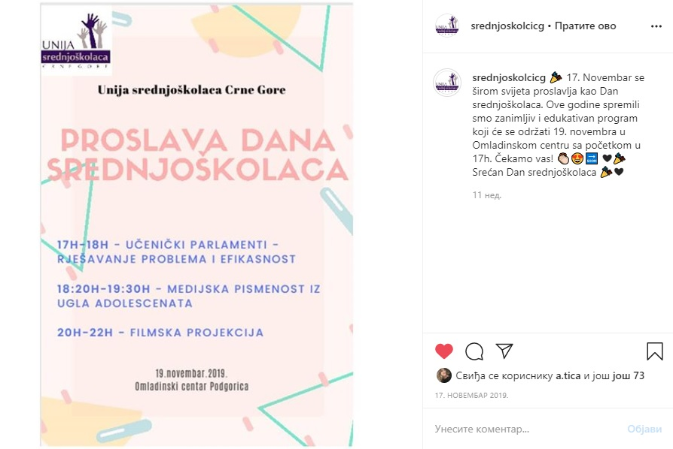

Collaboration with Seanema Film Festival.

The Union of High School Students of Montenegro has cooperated with the Seanema Film Festival.

Seanema is based on the idea that art must be democratic in a way that supports the human

interaction, as in this way, is initiated by the natural process of cultural, intellectual and political emancipation

of our society. In addition to the media, Seanema provides a physical space to open dialogues on a topic

social events in Montenegro.

The Seanem High School Students Union implements Seanem PopUP activity. This includes traveling to several Montenegrin cities.

During 2019, activities were implemented in Danilovgrad and Podgorica.

A screening of the short film Taurunum boy, at the Danilovgrad Cultural Center, was realized in Danilovgrad.

A short film night was held in Podgorica on December 21st at the Youth Center in Podgorica, starting at 5:00 pm, and a short screening of the short films awarded at the 5 years of the Seanema Film Festival took place.

Schedule 🎞: Soa | Montenegro | 22 '

Raisa | Moldova, Austria, Romania 15 '

A month | Kosovo 26 '

May Day | Belgium | 22 '

Last Image of Father | Serbia | 20 '

Brotherhood | Canada, Tunisia, Qatar, Sweden | 25 '

The Van | Albania, France | 15 '

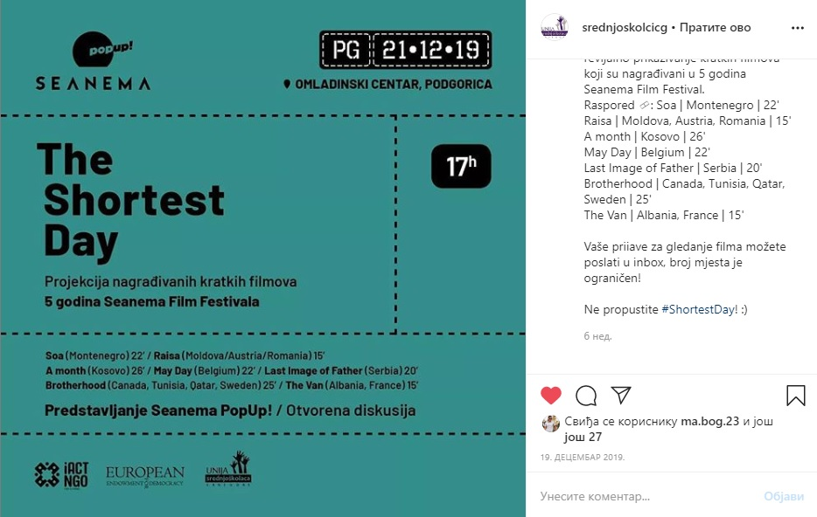

AIDS AWARENESS MONTH

The Association of High School Students of Montenegro understands the need for knowledge that is not offered in the regular school curriculum. It is for this reason and for the sake of healthy reproduction that the UNSCG has decided to work with gynecologists, psychiatrists and professionals with the experience necessary to deliver lectures on reproductive health and sexually transmitted diseases. In the southern region, 7 workshops were held, in the northern 13 and in the central 14.

22nd of decembre 2019

Indira Kolicic, High school students Union of Montenegro General secretary, has participted in talk show „Okvir“ on national TV servis under the topic „Youth in Montenegro included in decision making process“. Beside she, relevant people from Ministary for youth, mr Nenad Koprivica, centre for vocational education, Dusko Rajkovic, director of office for education, sport and and science, mr Radule Novovic and colleauges from NGO sector. During constructive discussion she has an oppurtunity to emphasise the important rule of our organisation in order to include youth in decission making process, how and why they are interested to take part in it and what is the biggest obstacles for them to volunteer and involve in youth politics.
She also had an interview for Vijesti TV under the line of drugs consumation between youth, how it is easy or not to buy it and what is the most common reason of using them. She also used the opportunity to mention our activities under the line of mental health and its importance.

https://www.facebook.com/watch/?v=471619976799352

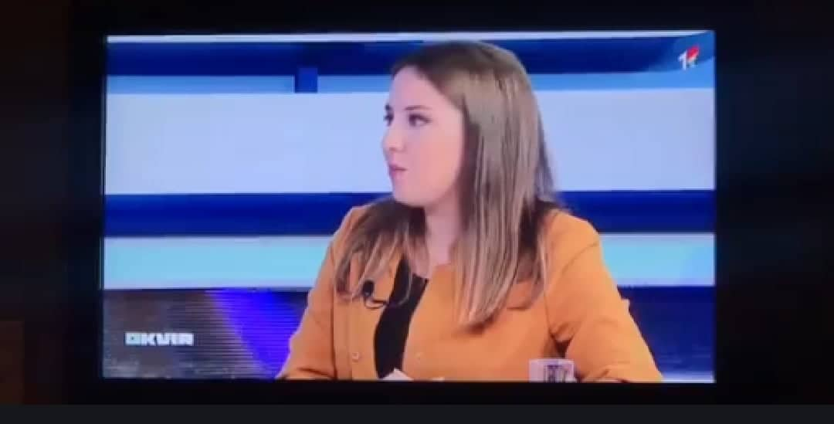

Training on strategic planning
Training on strategic planning was implemented after the General Assembly. Training was realized from December 20 to 21 in Podgorica.
The aim of the training on Strategic Planning was for the members of the Management Board to create a plan for a period of two years, which will be guided in the further work.
The training was led by Mićan Andrijašević, who together with the training participants went through different phases, as follows:
Weaknesses of the organization
Benefits of the organization
Affiliate support
Membership
Fundraising
Current and future competitions
Donors
Activities to be implemented and the like.

After the training, a draft version of the Strategic Plan was drafted, and then a final version of the Strategic Plan will be made.

Meeting on the 25th of August

After non-working summer days, the Board of Directors was again gathered on 25th of August to summarise the previous school year, and go trough the draft for next one.
The meeting was organized in the premises of Youth Center in Podgorica, and attended by :
Jovan Bojović - Secretary General, Varja Vukcevic- President of the Board, Balsa Bozovic- Coordinator for the Central Region, Bogdan Malavrazic- Coordinator for the Southern Region, Jelena Dobricanin- pr manager, President of the Assembly-Danilo Popović, Secretery of the Assembly - Milica Miranović.

Agenda :

- Summary of activities done in the former period
- Commenting on the draft for work that is awaiting
- Correcting the delegates list
- Visits to schools
- Workshops on peer violence

Conclusions:

It was agreed that after a few hurdles we had, we have to keep up with all obligations and fulfil everything expected. Milica and Danilo were said to be in charge of making a new delegates list, since a great number of them finished high school, and therefor cannot be an active part of the Union anymore.
We pointed out the importance of improving communication between delegates and regional coordinators, and found a way to do it – trough school visits.
Finally, we targeted first schools to be the part of peer violence workshops.

Meeting on 22th of September

The second meeting of our Board met again on 22th of September, again in the premises of Youth Center in Podgorica and was attended by : Jovan Bojović - Secretary General, Varja Vukcevic- President of the Board, Balsa Bozovic- Coordinator for the Central Region, Bogdan Malavrazic- Coordinator for the Southern Region, Jelena Dobricanin- pr manager, President of the Assembly-Danilo Popović, Secretery of the Assembly - Milica Miranović.
Agenda :

- General Assembly
- Workshops on peer violence

Conclusions:

We agreed upon the fact that workshops on peer violence should be expanded, so we raise awareness about red alert we have, when we talk about this topic. We believe that our concept targets all the individuals emerged in this problem – victims, neutral ones
(watchers) and violent ones. We also did a few workshops in elementary school, through the Coalition against peer violence.
This General Assembly, was partly a new thing for us, since a great number of the Board members did not participate in organizing it. We went through the accommodation offers, and other relevant hurdles, and chose the most suitable ones. In the future period, we agreed upon details important for this year’s GA. We contacted delegates and asked them about themes they prefer to work on during these 3 days.

Meeting on 15th of October

Agenda :

- Collecting funds from the employers who took part in the Action Day 2019
- Visits to counseling centers

Third meeting was organized on 15th of October, again in the premises of Youth Center in Podgorica and was attended by : Jovan Bojović - Secretary General, Varja Vukcevic- President of the Board, Balsa Bozovic- Coordinator for the Central Region, Bogdan Malavrazic- Coordinator for the Southern Region, Jelena Dobricanin- pr manager, President of the Assembly-Danilo Popović, Secretery of the Assembly - Milica Miranović.

Conclusions :

We went through a list of employers who still need to transfer their money, which was earned by our high school students. As previous years, we had a problem with employers who have delays with money transfers, so we guess we will have to deal with that in tye future time, as well. That being said, we decided that every part of the Board, should cover a number of emails, so we can contact them again, in order to remind them of their duties.
We alse talked about World AIDS Day, and activities we planned. The first one is Visits to counseling centers, which was coordinated by Jovan.

Meeting on 30th of October

The fouth meeting was organized on 30th of October, again in the premises of Youth Center in Podgorica and was attended by : Jovan Bojović - Secretary General, Varja Vukcevic- President of the Board, Balsa Bozovic- Coordinator for the Central Region, , Jelena Dobricanin- pr manager, President of the Assembly-Danilo Popović, Secretery of the Assembly - Milica Miranović.

Agenda :
- General Assembly

Conclusion:

Our Board met two days before the GA, so we could go through the agenda once again, and check whether everything is ok. We wished each other good luck and great work !

Meeting on 23th of November

The fifth and 2019 final meeting was organized on 23th of November, again in the premises of Youth Center in Podgorica and was attended by : Jovan Bojović - Secretary General, Varja Vukcevic- President of the Board , Jelena Dobricanin- pr manager, President of the Assembly-Danilo Popović, Secretery of the Assembly - Milica Miranović, Konstantin Vukic – person in charge for marketing and fundraising, Vladimir Perazic – Coordinator of South region, Bojana Ralevic – Coordinator of North region
Agenda:
- Welcoming new members of the Board
- World AIDS day
- New projects
- Resignation submitted by Balsa Bozovic

Conclusions :

At first, we welcomed new members of the Board, who where chosen, democratically,
on Union’s last General Assembly - Konstantin Vukic – person in charge for marketing and fundraising, Vladimir Perazic – Coordinator of South region, Bojana Ralevic – Coordinator of North region. Unfortunately, we faces another resignation, submitted by the coordinator of central region – Balsa Bozovic. Due to his obligations, he was forced to resign, as he said, because he could not give his best to our team. We believe that this will not be a huge obstacle in our future work. We went through the activities for World AIDS day, when we decided not to continue with distribution of condoms and lubricants, because we did not manage to get the donation for their buying, because their market prices are really high
We went through new project ideas, and did some brainstorming of our future activites.

