Godišnji izvještaj programa i aktivnosti Unije srednjoškolaca Crne Gore izrađuje se u formi narativnog izvještaja. Služi nam kao kratak osvrt na aktivnosti koje se realizuju u toku godine.
Izvještaj je sačinjen na engleskom jeziku, iz razloga što takav dostavljamo našim finansijerima (Schuler Helefen leben)

- MEDIA PROMOTION

Radio television Budva

Our delagate Vladimir Perazić was representing Union in radio show on Radio Budva called „Pet plus“ (Five plus) on the 24th of January. The show emphasizes interesting parts of everyday lives of young people in Budva municipality and Montenegro. Vladimir talked about Union and activities which will be done in upcoming period.
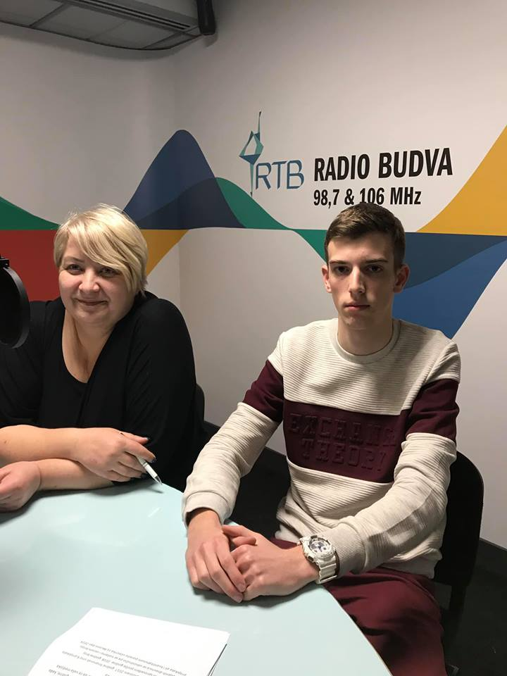

OKVIR

On 28th April two members of Administrative board of High School Student Union of Montenegro talked on a TV Show “Okvir” (“Frame”) about the Strategy for exercising children’s rights. The show was broadcast on the state television of Montenegro. Among the other speakers were representatives of state institutions such as Directorate for Social Welfare and Children's Protection, National Office for Combating Trafficking in Human Beings, and Ministry of Education.

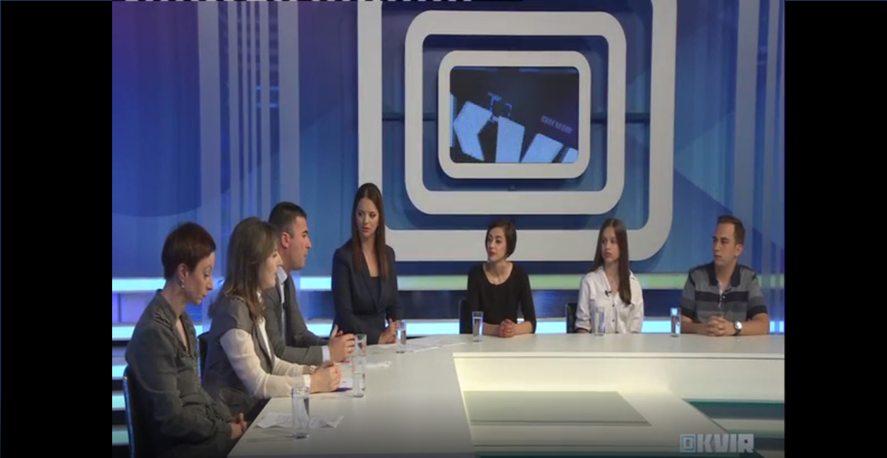

At the very beginning Jelena, our PR manager, mentioned Union’s contribution to the development of the Strategy. The Union conducted consultations with adolescents to point out key problems that young people encounter. Peer violence and discrimination were the most distinguishable problems. She pointed out that those were the topics Montenegrin society talks about a lot, but rarely acts upon.

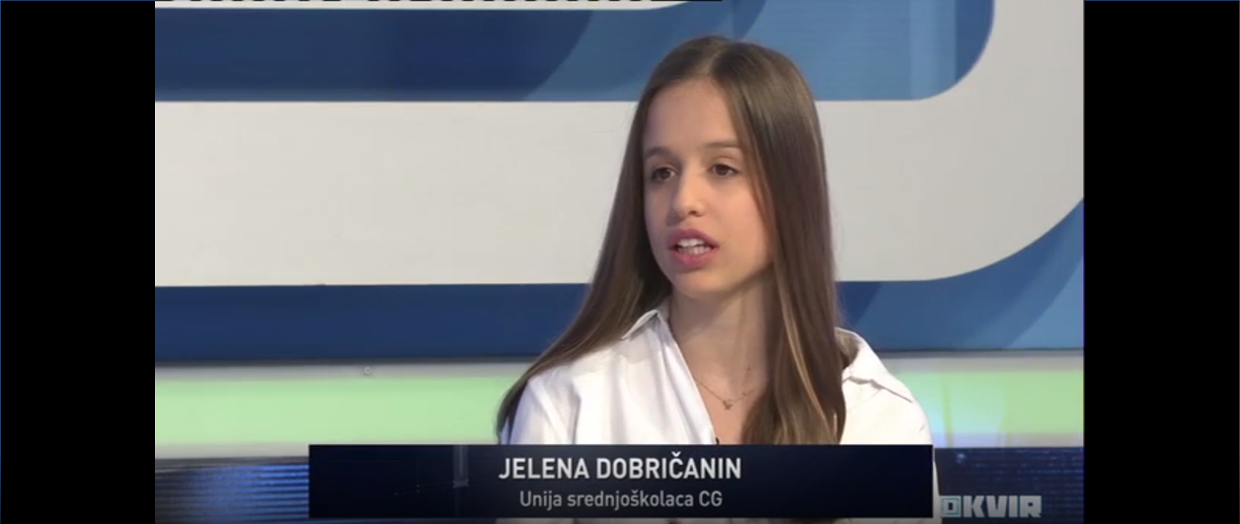

President of the Union’s Assembly, Danilo, noted that those weren’t the only problems adolescents encounter. When answering the question of where he sees the greatest space for progress in exercising children’s rights, he replied that the answer lies in the results of the research. Solving problems like peer violence, discrimination, lack of understanding from older people (professors, parents etc) as well as lack of understanding from their peers, represents the path of progress. Improvement of educational system in Montenegro plays a key role as well.

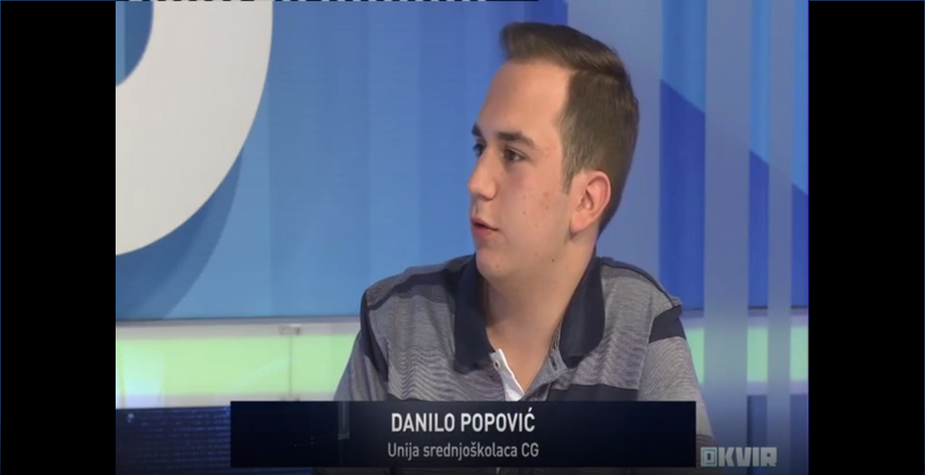

When talking about education as one of the key elements of adolescent life, members of Union pointed out informal education as one of the fields High School Student Union of Montenegro operates in.

On May 3th 2019, President of the UNSCG Varja Vukčević was a guest on television TV777 regarding Action Day 2019. She talked about the Action Day itself, its iprovement during the years but also about young people in general. It was talked about why they are so unmotivated and not willing to make a change.

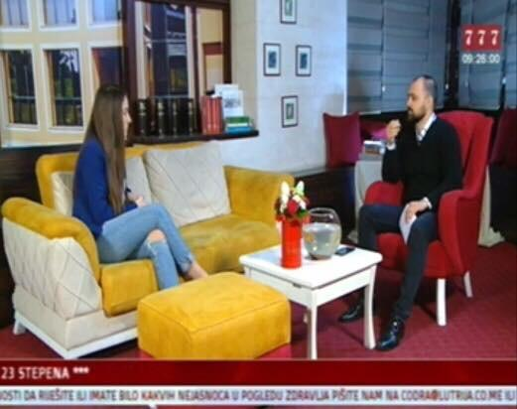
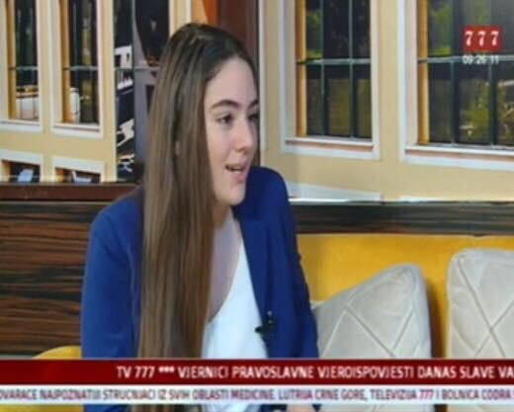

On May 4th 2019, President of the UNSCG Varja Vukčević was a guest on National television RTCG regarding Action Day 2019. She was mainly talking about all the benefits the Action Day brings such as finding your true passion, making new acquaintances etc... Also, the previous Action Days and experiences were mentioned . She invited all high school students that are interested in this project to take part in it.

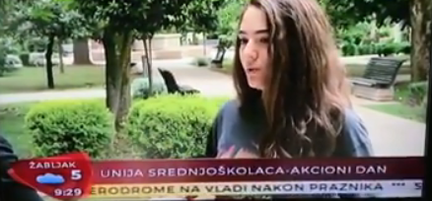

On May 2nd 2019, Coordinatior of Central Region of the UNSCG Balša Božović was a guest on National television Vijesti to talk about then upcoming Action Day 2019. He noted that there was no selection regarding choosing high school students that will participate in Action Day and that anyone could take part in it. He also talked about significant improvement in organization and size
of the Action Day.

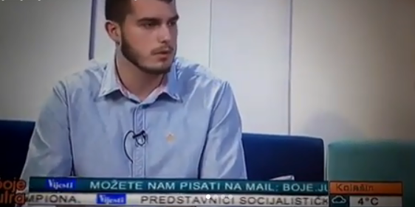

On May 15th 2019, PR Menager of the UNSCG Jelena Dobričanin was a guest on television TV777 to talk about Action Day after it was realized and to sum up all the impressions. She talked about general improvement of Action Day during the years. She also emphasized that this was the most succesfull Action Day regarding numbers and also that the impressions were great.

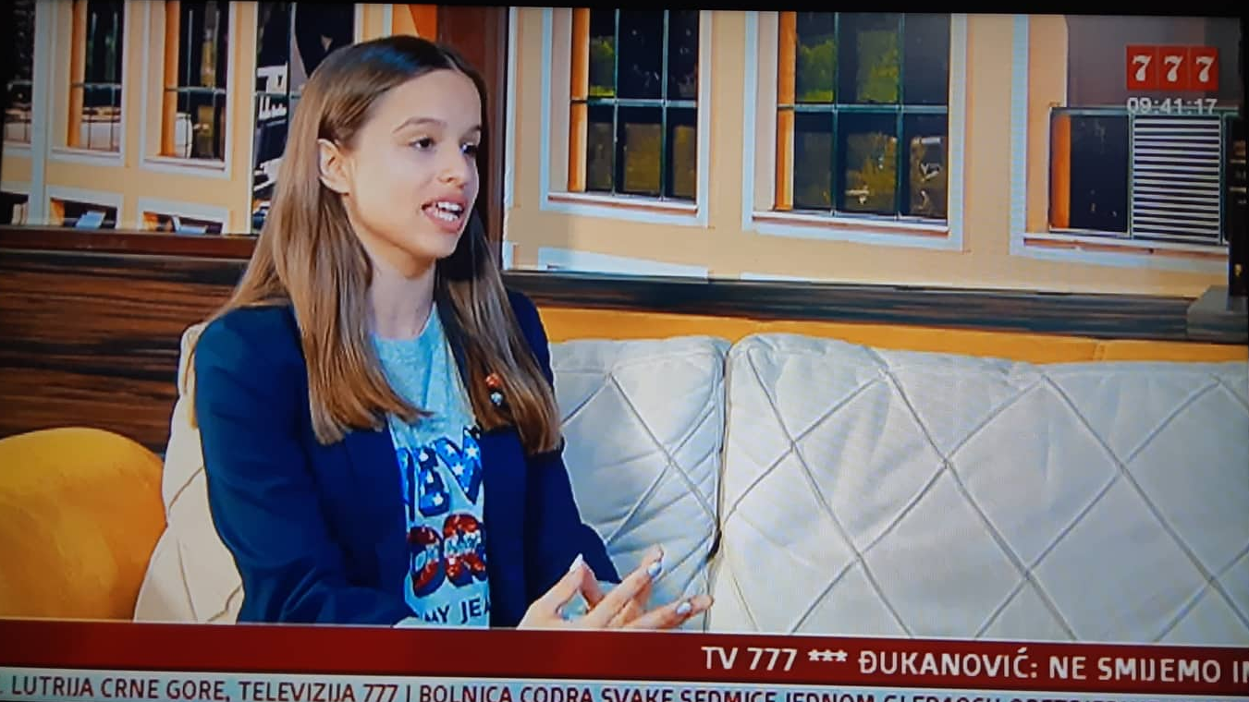

On May 17th 2019, PR Menager od the UNSCG Jelena Dobričanin talked about a common issue in our country on national television Vijesti. It was about why young people want to and leave Montenegro in order to find a better place to live in. Among other things it was stated that young people are unmotivated and are not willing to make a change.

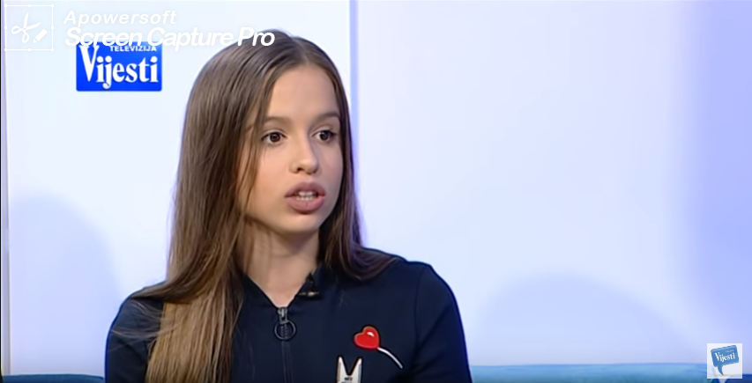

On June 28th 2019, PR Menager of UNSCG Jelena Dobričanin was a guest on national television TV Vijesti where she talked about importance of speaking in a proper way and according to the rules. She also talked about sleng and other types of words that are slowly making their way into the language and why do young people use shortened words more and more.
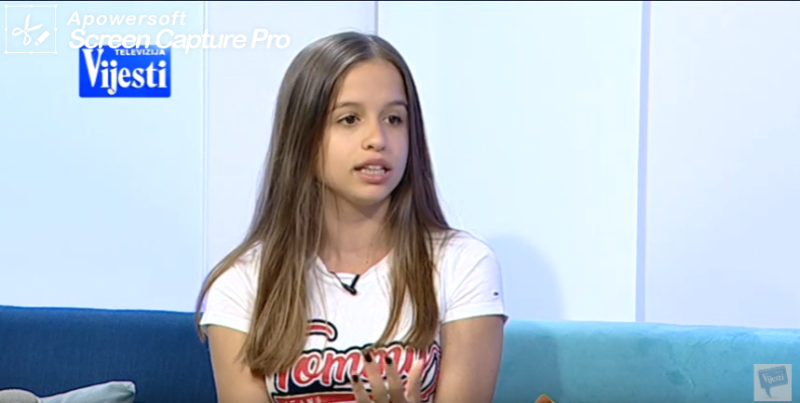

- MEETINGS

Meeting with Michael Hilbert

On the 24th of March, Michael Hilbert, contact person from SHL, visited UNSCGs office in Podgorica. Andrea, Jovan and Varja shared different thoughts and ideas about future activities and organization between SHL and UNSCG.

Dalje idu tvoji meetings

- EVENTS

FES SEMINAR IN BELGRADE

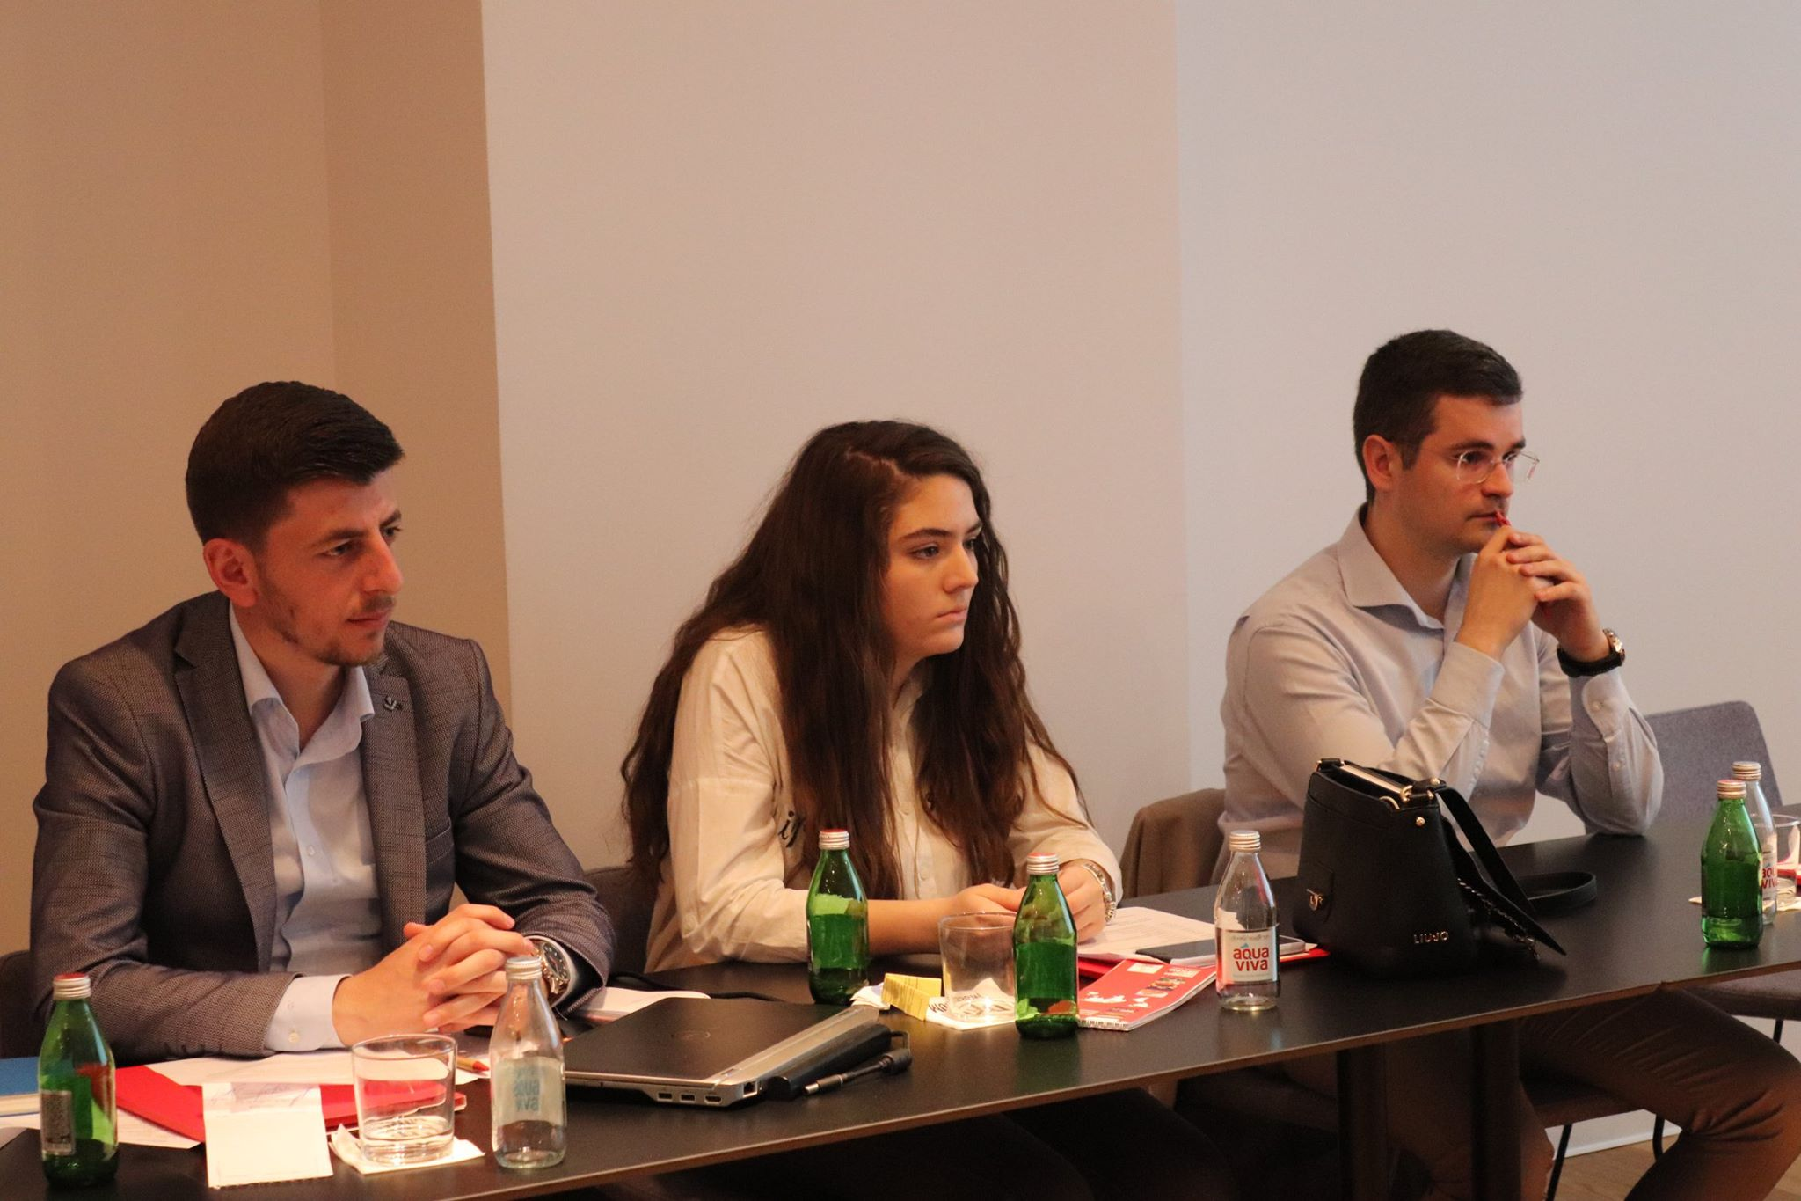
President of the Board of directors, Varja Vukcevic, participated in a seminar held from 21th until 23th of March, in Belgrade, Serbia. Organised by FES (Friedrich Ebert Stiftung Prishtina office), seminar was focused on forming a new legal body-Youth Regional Voice, which would help young people from 6 Western Balkans countries (Serbia, Montenegro,Kosovo, Bosnia and Herzegovina, Croatia and Macedonia) solve different problems, they come across in everyday situations. During this seminar, participants succeeded in forming the body’s structure and Statute.

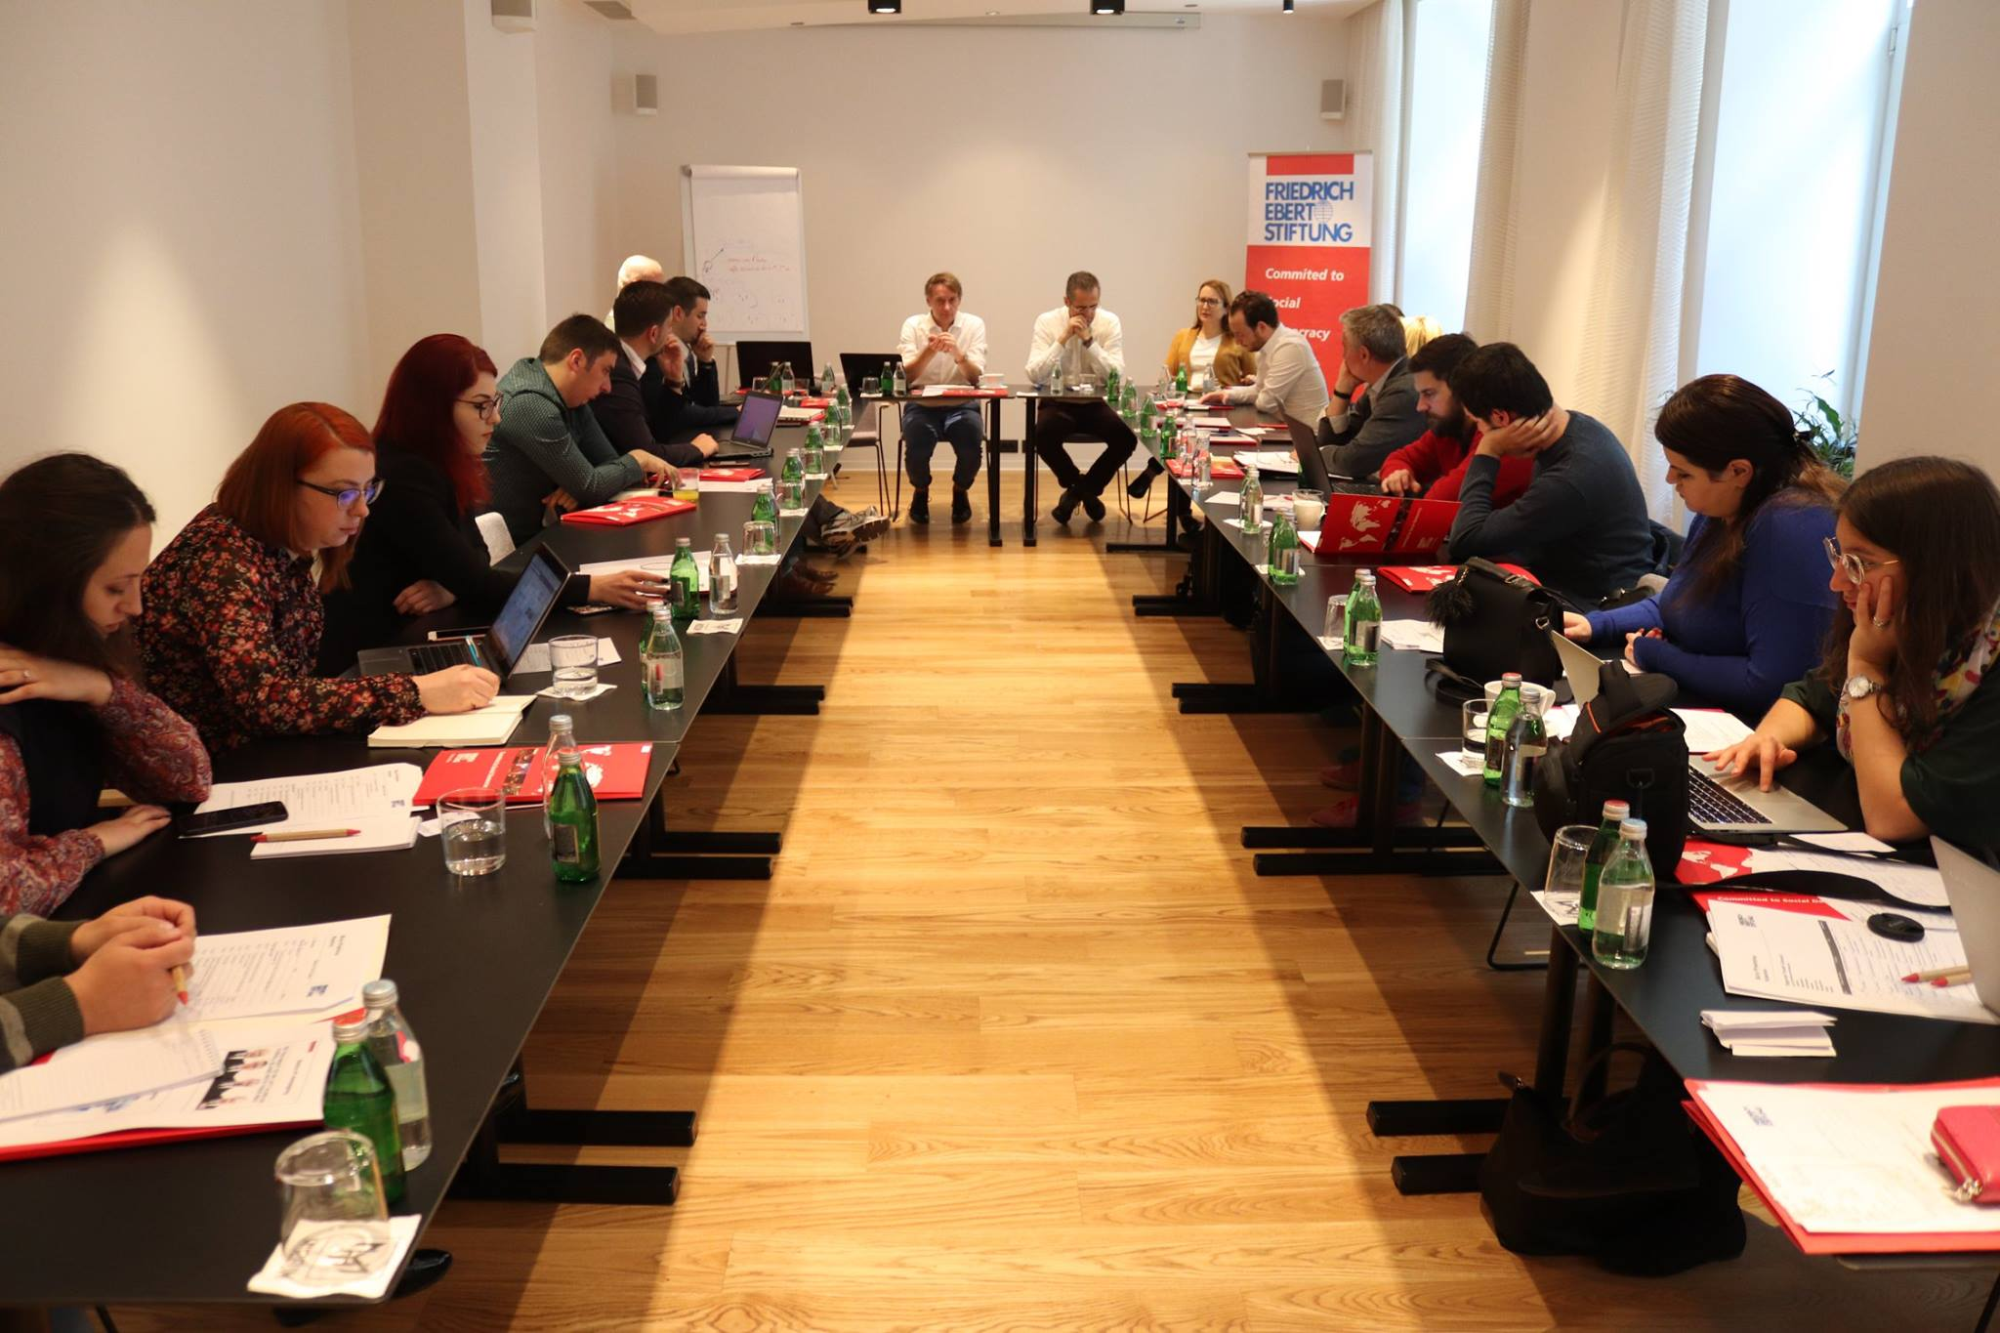
Those three days were spent in extremely productive way, because the presenters of member organizations were full of new and innovative ideas such as : creating websites for research purpose, developing better functioning ideas, etc..
MINISTERIAL CONFERENCE

On April 5th, PR Menager Jelena Dobričanin participated in Ministerial Conference which was organized by Ministry of Sports and Youth of Montenegro in Hotel Splendid in Budva. They talked about strengthening regional and Adriatic-Ionian cooperation in the field of youth and also about Adriatic -Ionian Initiative, Berlin process, EYCA, RYCO etc..
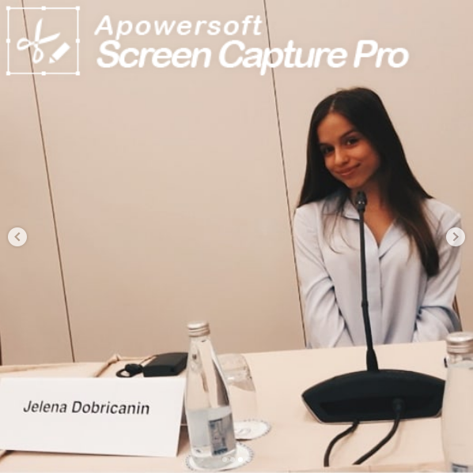

All of the countries invited had the opportunity to talk about the current state of youth policy in their country. One of the most important issues were how to make young people more involved and more interested in making a change in their community. Also, how to make them more connected through RYCO, EYCA and other ways simmilar to those. The conclusion was that youth activism should be more promoted through social media and in general in order for it to get the bigger reach. Also that young people should be more involved by adults and that they should be taken more seriously.

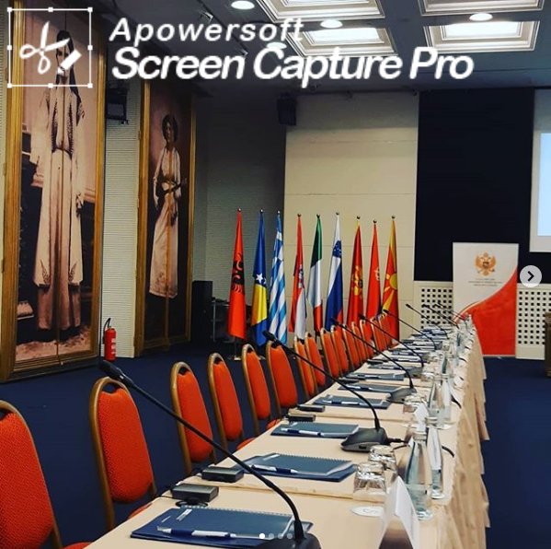
THEIR SMILE IS WOTH MORE

On 14th April, a member of Administrative board of High School Student Union of Montenegro participated in a humanitarian action within a project “Their smile is worth more”. It is a project in which Union is a partner of the National Smile organisation. It is a project in which elementary school, high school, and university students donate supplies to the only institution that takes care of children deprived of parental care and children whose development is hampered by family circumstances.
Union took part in organising the charity funding by helping high school student parliaments organise collecting of donations in every high school in Montenegro. Donations were provided in forms of garments, school supplies, toys, and hygienic accessories, which were carefully packed in decorated gift boxes.

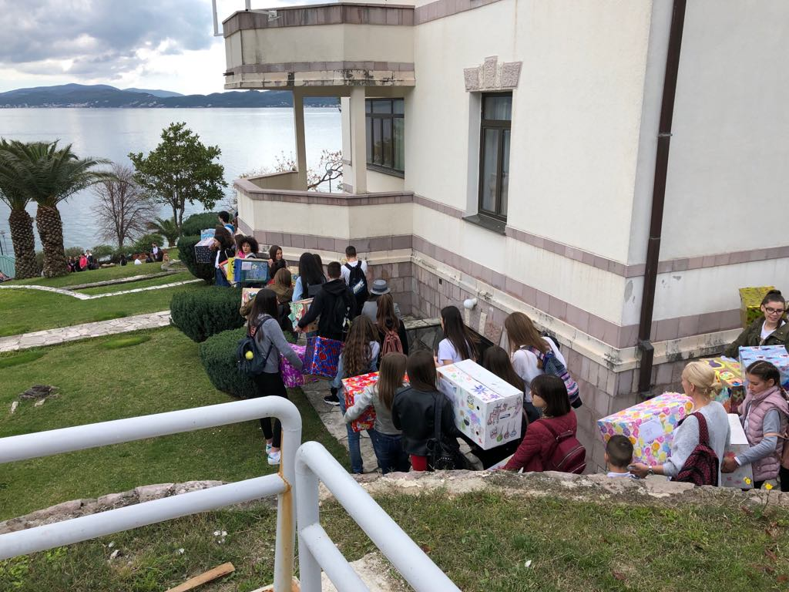

The central event took place on 14th April, when National Smile organisation organised transport to Bijela, where the Orphanage “Mladost” is located. It was a joyful day when everyone had one goal in mind: to put a smile on the kids’ faces.

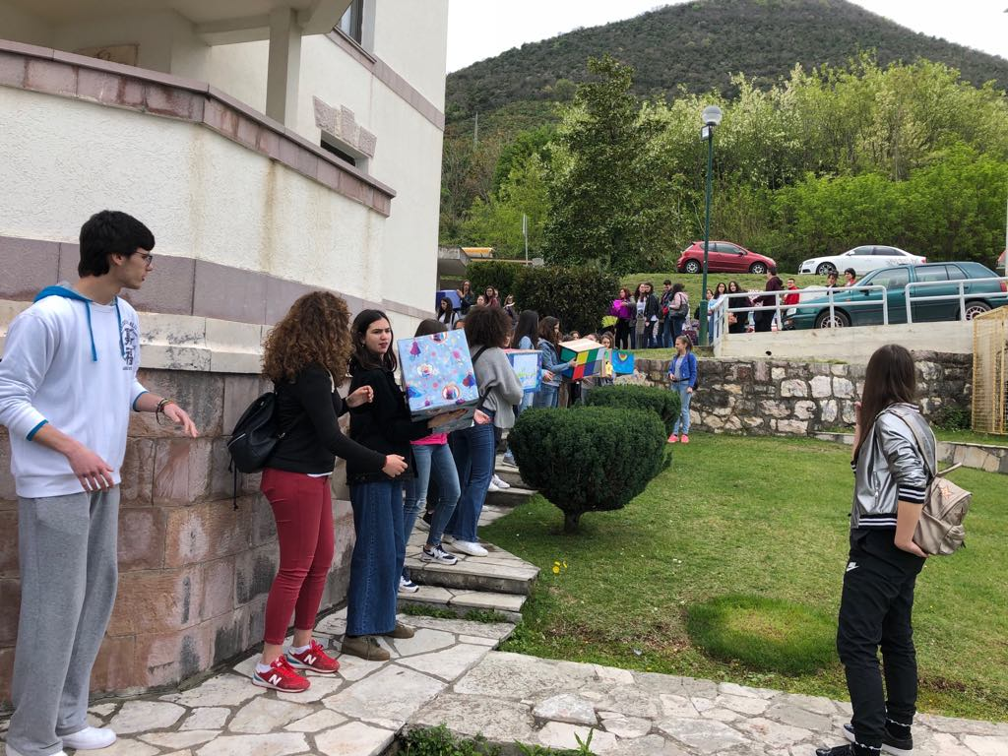
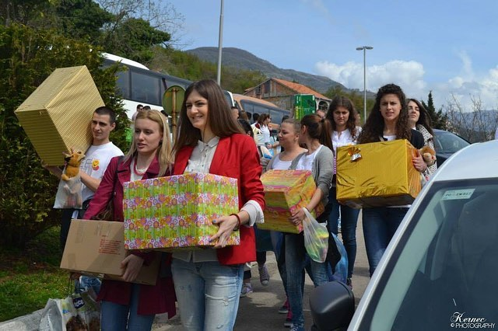

CONFERENCE “ VIOLENCE IS FOR THE WEAK ONES “

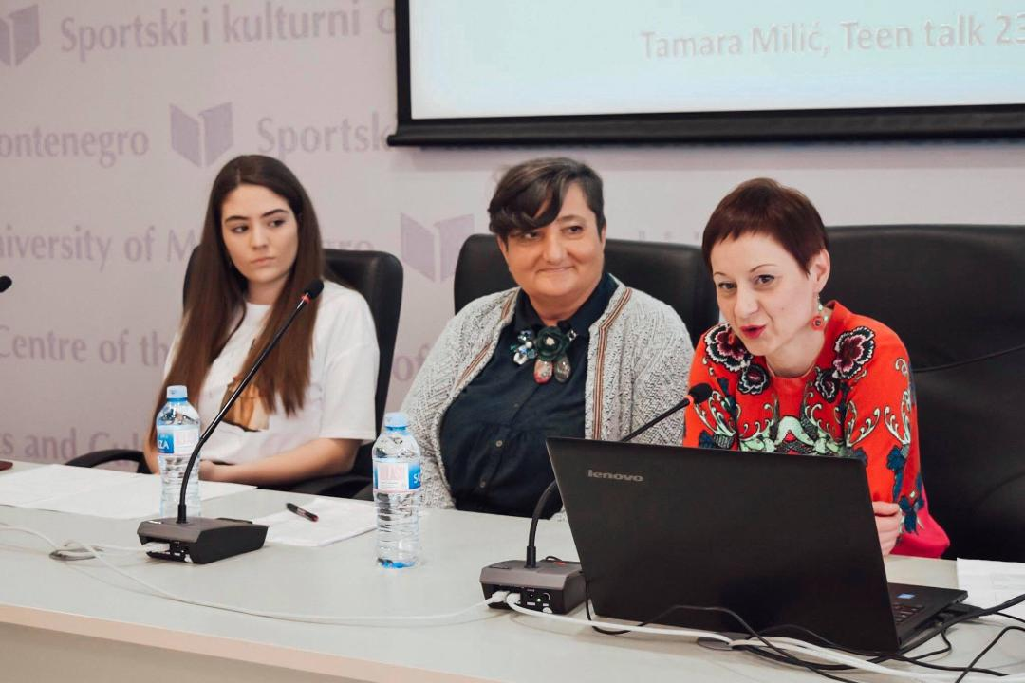
Our president of the Board of directors, Varja Vukcevic, was one of the panelists on a conference held on the 27th of April in Podgorica, Montenegro, named: “Violence is for the weak ones”. The main topic of this discussion was peer violence and ways, in which we should try to prevent it. Whole program was adjusted for teenage audience, which were carefully listening, the whole time.

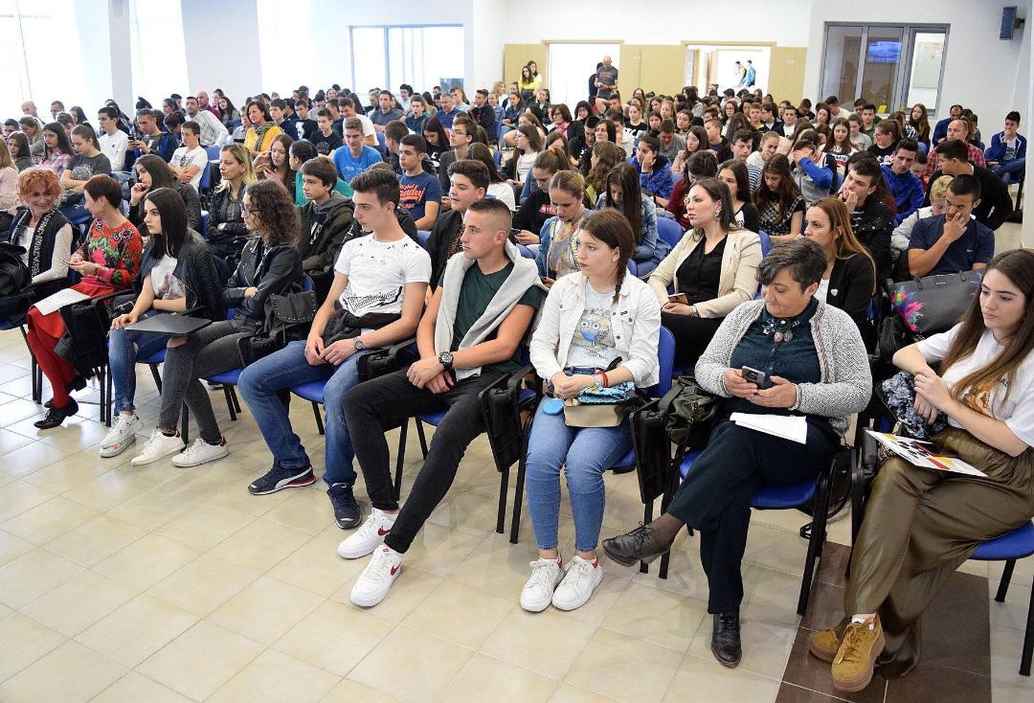
Our representative had a chance to clarify the rule on UNSCG, concerning certain topic. She pointed education and prevention as one of the key factors and promoted different range of activities and opportunities UNSCG can provide for adolescents.

